UAT – LAS Platform (Create Class)
 | Path | Comment
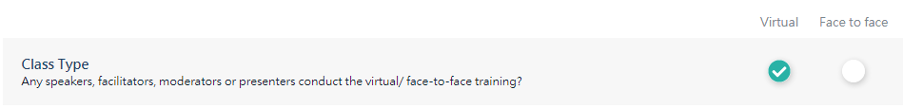 | Create Class Class Information | The choices should be “Yes””No”, but not “Virtual””Face to face”.  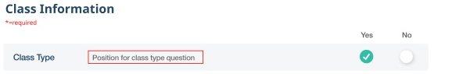
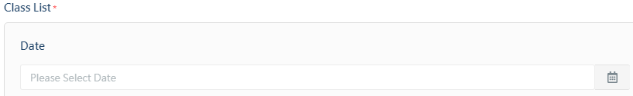 | Create Class Class Information (Face to Face)  Create Class Class Information (Face to Face)  Create Class Class Information (Face to Face) | Doesn’t work when clicked on the calendar icon. You may want to check the calendar icon in other field as I saw Peggy has the same comment for another field.
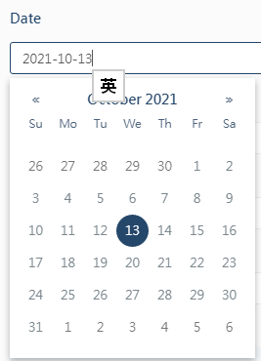 |  | Can the calendar disappear once picked the date?
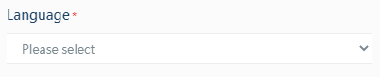 |  | Can it change to input to search? As there are many irrelevant language in the LMS library.
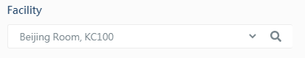 |  | - Change to “Please select” like the Language one as it is not mandatory field. The class may not have “real” training venue.  - What is the purpose of the searching icon? (and it is not working)
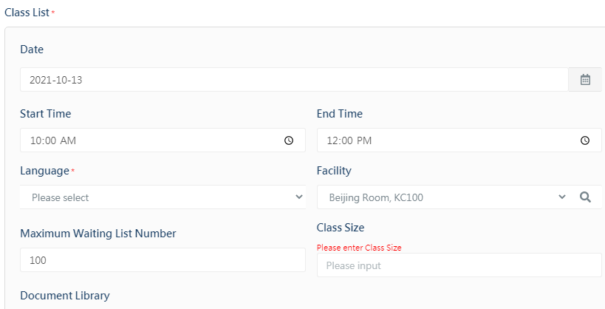 |  | - Only Language has marked *, but many other fields are mandatory.
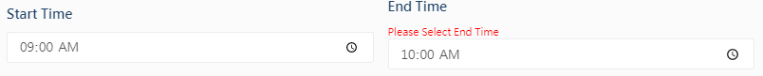 |  | Always not allowed to proceed next time because of the time.

