Upload course, Class and Enrolment data from LAS to LMS

Overview
Currently, some courses are created by department themselves, but no complete information created in Saba Cloud Learning Management System (“LMS”) yet.

This enhancement is to allow department users to import course, class, enrolment, and course attachment (if any) to Learner Attendance System (“LAS”) , after validation in LAS, those data will be upload to LMS automatically.

This enhancement will also allow department users to upload virtual training (ie Zoom and Webex training) attendance record to LMS via LAS.

Key points for LAS:
- the import file to LAS is a pre-defined excel format
- LAS is required to validate the import data and ensure data is all correct according to the data format (further define in detailed requirement) before synchronizing (“export” ) to LMS
- the interface with LMS will be done by API
- LAS can handle 2 cases: course is already in LMS, the other is the course is not yet in LMS

System Flow
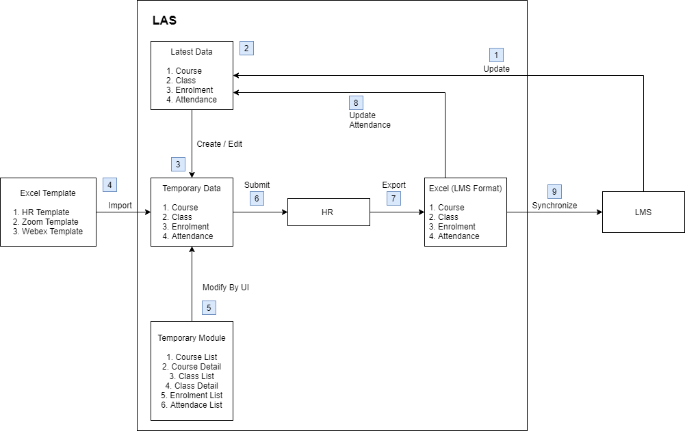
- Class, enrolment, attendance data from LMS will syncronize to LAS every night or when user press “Sync All from Saba” button. In this enhancement, course data should be syncronize for HR user to manipulate course.
- LAS store the course, class, enrolment, attendance data in database.
- When system user update any learning data (= course information, class information, enrolment record, attendance data), system will clone the affected data to temporary table.
- Divisional Coordinator (“System user”) is allowed to upload a excel file to create the learning data.
- System user is also allowed to create learning data by UI in LAS.
- When the changes are ready, system user need to submit the confirmed changes to HR user for review.
- HR user could check the correctness of the learning data in excel format.
- Once the learning data are reviewed and confirmed by HR, HR user could synchronize the course, class, enrolment data to LMS. If the learning data are reviewed but updated by HR, notification shall send to system user and copy LnD@bocigroup.com.
- For the attendance data, system will save it to the main attendance table.

Involved fields
The following sections show the fields in LMS which will be involved for synchronize the learning data from LAS to LMS.

Course
Involved fields – Course
Field Name | Required fields | HR Form | User Form | User Form (advance) | Default value
Main Tab – Course Details
Title | LMS | ✔ | ✔
Course ID | LMS | ✔ | ✔ |  | Generate by system
Domain | LMS | ✔ | ✔
Abstract | HR | ✔ |  |  | Refer to description field
Description | HR | ✔ | ✔
Create group | HR | ✔ |  |  | False
Is Sensitive | HR | ✔ |  | ✔ | False
Hide Score | HR | ✔ |  |  | True
Show web 2.0 function | HR | ✔ |  |  | False
Can Waive | HR | ✔ |  |  | False
Hide Classmates | HR | ✔ |  |  | False
Target Days | HR | ✔ |  |  | False
Owner | HR | ✔ |  |  | Owners from Class List
Main Tab – Pricing Information
Currency | HR | ✔
Price | HR | ✔
Main Tab – Availability Information
Available From | LMS | ✔ | ✔
Discontinued From | HR | ✔ |  | ✔
Display for Call Center | HR | ✔ |  |  | False
Display for Learner | HR | ✔ | ✔ |  | False
Featured | HR | ✔ |  |  | False
Main Tab – Other Information
Type | HR | ✔
Method1 | HR | ✔
Method2 | HR | ✔
HO Type (1) | HR | ✔
HO Type (2) | HR | ✔
CPT | HR | ✔
OPT | HR | ✔
IA CPD | HR | ✔
MPFA CPD | HR | ✔
Entitle for CPT/OPT | HR | ✔
Year | HR | ✔ |  |  | Year of the class
Sub Category | HR | ✔
Related Info Tab
Category | HR | ✔
Skill | HR | ✔ |  | ✔
Policies Tab
Available Languages | HR |  |  |  | Language from class list
Notifications Tab
All | HR | ✔
Course due date reminder | HR | ✔ |  | ✔
Additional Field
Document (Legal) | HR | ✔ | ✔

Instructor-Led Training (“ILT”) Class
Involved fields – ILT Class
Field Name | Required fields | HR Form | User Form | User Form (advance) | Default value
Main Tab – Course Details
Course ID | LMS | ✔ | ✔ |  | Generate by system
Class ID | LMS | ✔ | ✔ |  | Generate by system
Domain | LMS | ✔ | ✔ |  | Generate by system
Description | HR | ✔ | ✔ |  | Refer to description field
Owner | HR | ✔ | ✔ |  | Creator
Main Tab – Scheduling Details
Start Date | LMS | ✔ | ✔
Session Template | LMS |  |  |  | Generate by system
Duration | LMS | ✔ | ✔ |  | Generate by system
Location | LMS | ✔ | ✔ |  | Auto selected when user selected facility
Facility | HR | ✔ | ✔
Language | LMS | ✔ | ✔
Main Tab – Pricing Information
Currency | HR | ✔
Price | HR | ✔
Main Tab – Registration Information
Min count | LMS | ✔ |  | ✔ | 1
Max count | LMS | ✔ |  | ✔ | 80
Max in wait list | LMS | ✔ |  | ✔ | 100
Allow drop | HR | ✔ |  | ✔ | True
Allow drop date | HR | ✔ |  | ✔
Main Tab – Availability Information
Display for call center | HR | ✔ |  |  | False
Display for learner | HR | ✔ | ✔ |  | False
open enrollment date | HR | ✔ |  | ✔
enrollment closes before | HR | ✔ |  | ✔
Main Tab – Other Information
Year | HR | ✔ |  |  | Language from class list
Expenses Tab
Budgeted Expenses | HR | ✔
Actual Expenses | HR | ✔
Policies Tab
Audience Type | HR | ✔ | ✔ |  | All BOCI Employees
Notifications Tab
All | HR | ✔
Successfully Enrolled | HR | ✔ |  | ✔
Class Reminder | HR | ✔ |  | ✔
Class Cancelled | HR | ✔ |  | ✔
Class Facility Changed | HR | ✔ |  | ✔
Class Rescheduled | HR | ✔ |  | ✔
Registration Waitlisted | HR | ✔ |  | ✔
Registration Confirmation from Waitlist | HR | ✔ |  | ✔

Web-Based Training (“WBT”) Class
Involved fields – WBT Class
Field Name | Required fields | HR Form | User Form | User Form (advance) | Default value
Main Tab – Course Details
Course ID | LMS | ✔ | ✔ |  | Generate by system
Class ID | LMS | ✔ | ✔ |  | Generate by system
Domain | LMS | ✔ | ✔ |  | Generate by system
Description | HR | ✔ | ✔ |  | Refer to description field
Owner | HR | ✔ | ✔ |  | Creator
Main Tab – Scheduling Details
Duration | LMS | ✔ | ✔ |  | Generate by system
Language | LMS | ✔ | ✔
Main Tab – Pricing Information
Currency | HR | ✔
Price | HR | ✔
Main Tab – Registration Information
Allow Drop | HR | ✔ |  | ✔ | No, this class cannot be dropped after registration
Main Tab – Availability Information
Available from | LMS | ✔ | ✔
Discontinued From | LMS | ✔ |  | ✔
Display for Call Center | LMS | ✔ |  |  | False
Display for Learner | HR | ✔ | ✔ |  | False
Main Tab – Other Information
Year | HR | ✔ |  |  | Language from class list
Expenses Tab
Budgeted Expenses | HR | ✔
Actual Expenses | HR | ✔
Policies Tab
Audience Type | HR | ✔ | ✔ |  | All BOCI Employees
Notifications Tab
All | HR | ✔
Successfully Enrolled | HR | ✔ |  | ✔

Retrieve additional data from Saba
Currently, a cron job will be run at everyday midnight (1 hour after HR sync job run from Saba) to retrieve class, session, learner, and enrollment data from Saba. For the enhancement, cron job will also retrieve the course and WBT class data. Below is the list of APIs which will be executed.

Involved API and Fields
- Retrieve course data from Saba by API
Course information
Saba API | Saba Field | Description
Get All Courses (/course?count=:count&startPage=:startPage) | id | Course id
Get the details of a particular course (/course/:id:(:searchFields)) | title  securityDomain.id  abstrac  description  createGroupPolicyVal  is_sensitive  suppress_score  show_web2_0_actions  can_waive  hide_classmates  target_days  owner.owner.id  allPrices.curr_id  allPrices.amount  avail_from  disc_from  avail_call_center  avail_web  language.id  featured  category.id  category.name  associations.skills  customValues.custom0  customValues.custom1  customValues.custom2  customValues.custom3  customValues.custom4  customValues.custom5  customValues.custom6  customValues.custom7  customValues.custom8  customValues.custom9  customValues.custom10  customValues.custom11 | Course title  domain id  abstract (limit: 1000)  description (limit: 2000)  create group  is sensitive  hide score  Show Web 2.0 functions  Can Waive  hide classmates  target days  owner id  currency  price  available from  discontinued from  display for call center  display for learner  language id  featured  category id  category name  Type  Method1  Method2  HO Type (1)  HO Type (2)  CPT  OPT  IA CPD  MPFA CPD  Entitle for CPT/OPT  Year  Sub Category
Get all security domains (/domain?count=:count&startPage=:startPage) | description  name  id | Description  Domain Name  Domain ID
Find the details of the currencies (/currency?q=(:criteria_field%3D%3D:field_value)&count=:count&startPage=:startPage) | id | Currency ID
Get the details of a particular currency (/currency/:id:(:searchFields)) | id  name  iso_code | Currency ID  Currency name  Iso code
Find the details of the Language (/language?q=(:criteria_field%3D%3D:field_value)&count=:count&startPage=:startPage) | name  id  isDefault | Language name  Language ID  is default
Get All Categories (/learning/category) | id | Category ID
Get Category Details (/learning/category/:categoryId) | name  context | Category name  Context id
- Retrieve ILT class data from LMS by API
ILT class information
Saba API | Saba Field | Description
Get the details of an class (/offering/:offeringId) | securityDomain.id  classDescription  owner.id  startDate.dateInUserTimeZone  Duration  Location.id  Facility.id  language_id.id  allPrices.amount  allPrices.curr_id.id  min_ct  max_ct  max_book  do_not_drop_post.dateInUserTimeZone  disp_for_web  disp_for_call_center  open_enroll.dateInUserTimeZone  enroll_close.dateInUserTimeZone  customValues.value | domain  description (limit: 2000)  owner id  start date  Duration  Location  Facility  Language  amount  currency name  minimum count of class  maximum count of class  Max In Wait List  Allow Drop  Display for learner  Display for call center  Open Enrollment Date  Enrollment Closes Before  Year
Find the details of the Locations (/location?q=(:criteria_field%3D%3D:field_value)&count=:count&startPage=:startPage) | id  loc_name | Location ID  Location name
Find the details of the Facilities (/facility?q=(:criteria_field%3D%3D:field_value)&count=:count&startPage=:startPage) | id  name | Facility ID  Facility name
Find the details of the currencies (/currency?q=(:criteria_field%3D%3D:field_value)&count=:count&startPage=:startPage) | id | Currency ID
Get the details of a particular currency (/currency/:id:(:searchFields)) | name  iso_code  short_name | Currency name  Iso code  Short name
- Retrieve WBT class data from LMS by API
WBT class information
Saba API | Saba Field | Description
Get All classes (/offering?type=:type&count=:count&startPage=:startPage) | id | Class ID
Get the details of an class (/offering/:offeringId) | offeringTemplate.id  securityDomain.id  owner.id  classDescription  language_id.id  Duration  allPrices.amount  allPrices.curr_id.id  do_not_drop_post  avail_from.dateInUserTimeZone  discontinued.dateInUserTimeZone  disp_for_web  disp_for_call_center  customValues.value | Course ID  Domain  Owner ID  description (limit: 2000)  Language  Duration  amount  currency name  Allow Drop  Available from  Discontinued From  Display for Learner  Display for Call Center  Year
Get All AudienceTypes (/audiencetype?count=:count&startPage=:startPage) | id  name | id  name
Get All Sub Audience Types (/subaudiencetype?count=:count&startPage=:startPage) | id  name | id  name

Course Data

Get all courses
Source API (Get All Courses) /course?count=:count&startPage=:startPage
Parameter | Value
count | 10
startPage | 1
Remarks:
Keep call this API until the “hasMoreResults” is false
Get all course id
Request:
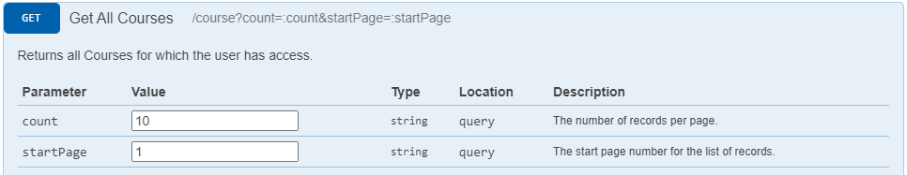
Response:
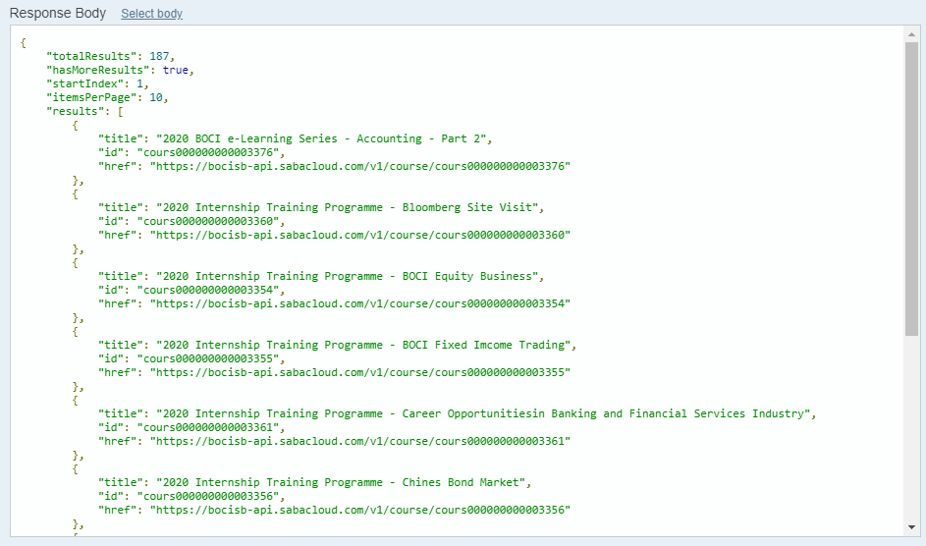

Get course details
Source API (Get the details of a particular course) /course/:id:(:searchFields)
Parameter | Value
id | cours000000000003360
searchFields
Query String | includeassociation=true
Remarks:
Retrieve the following course data:
- Course details tab
title, domain id, abstract, description, create group, is sensitive, hide score, show web 2.0 functions, can waive, hide classmates, target days, owner
- Pricing information tab
currency, price
- Availability information tab
available from, discontinued from, display for call center, display for learner, featured
- Other information tab
type, method1, method2, HO type (1), HO type (2), CPT, OPT, IA CPD, MPFA CPD, Entitle for CPT/OPT, Year, Sub Category
Example of API call:
https://bocisb-api.sabacloud.com/v1/course/cours000000000003376?includeassociation=true&SabaCertificate=xxx
Request: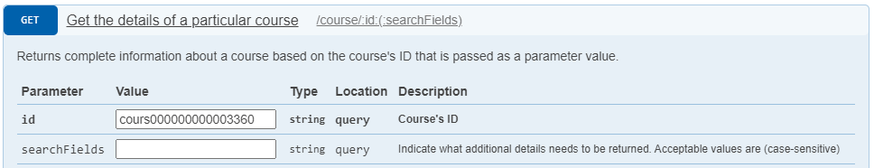
Response: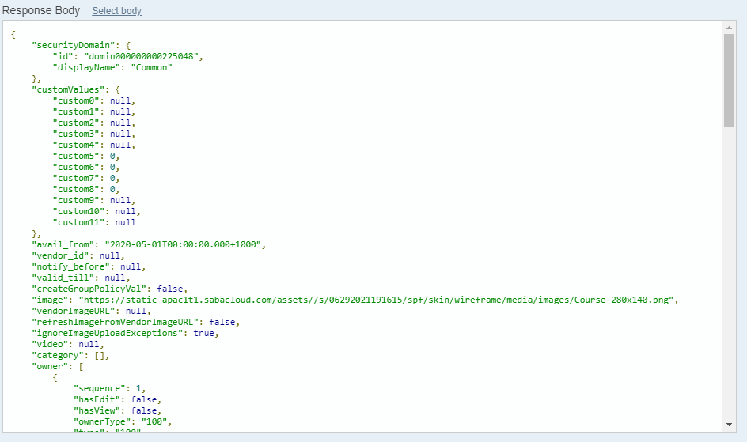

Get all security domain
Source API (Get all security domains) /domain?count=:count&startPage=:startPage
Parameter | Value
count | 10
startPage | 1
Remarks:
Keep call this API until the “hasMoreResults” is false
Get all security domain data for selection in courses and classes
Request: 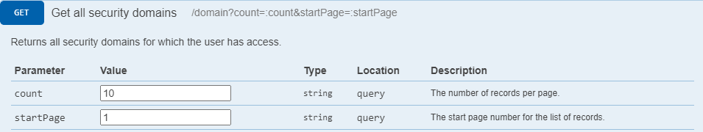
Response: 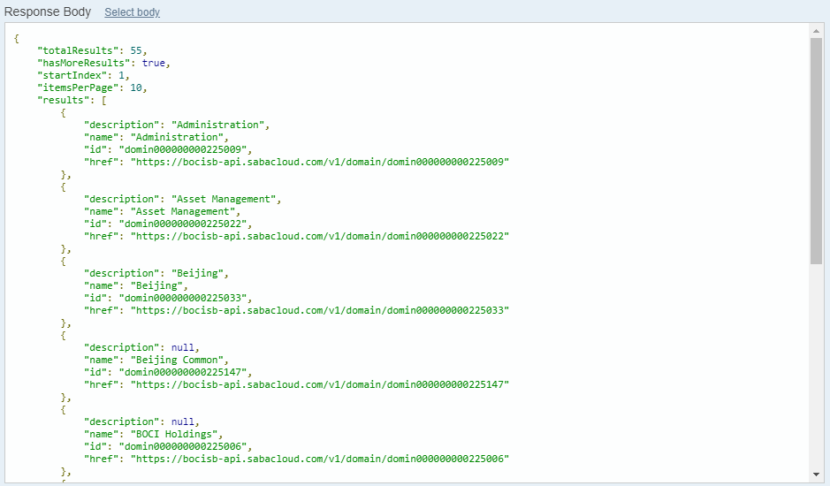

Get all active currency data
Source API (Get the details of a particular currency) /currency/:id:(:searchFields)
Parameter | Value
criteria_field | active
field_value | 1
count | 10
startPage | 1
Remarks:
Keep call this API until the “hasMoreResults” is false
Get all active currency data for selection in courses and classes
Request: 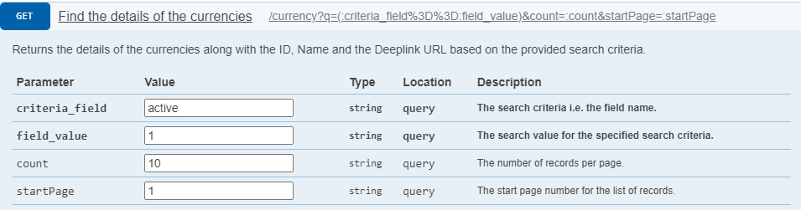
Response: 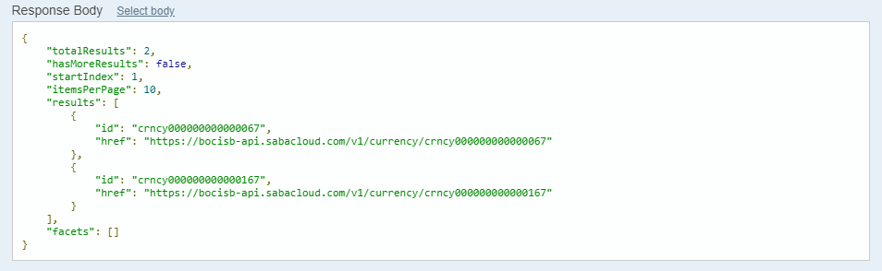

Get the details of currency
Source API (Get the details of a particular currency) /currency/:id:(:searchFields)
Parameter | Value
id | crncy000000000000067
searchFields | id,name,iso_code
Remarks:

Request: 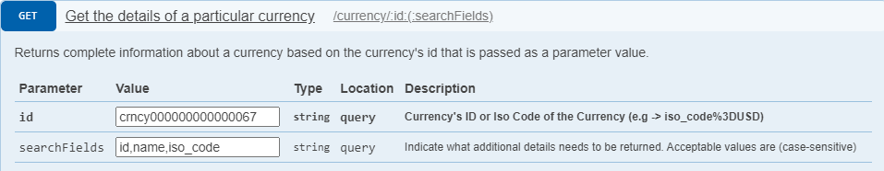

Response: 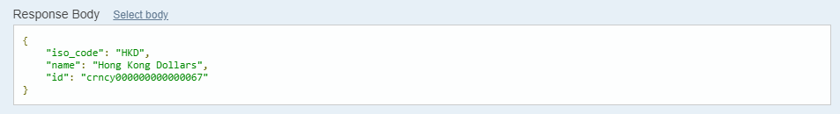

Get all enabled language
Source API (Find the details of the Language) /language?q=(:criteria_field%3D%3D:field_value)&count=:count&startPage=:startPage
Parameter | Value
criteria_field | isEnabled
field_value | true
count | 10
startPage | 1
Remarks:
Keep call this API until the “hasMoreResults” is false
Get all enabled language for selection in courses and classes
Request: 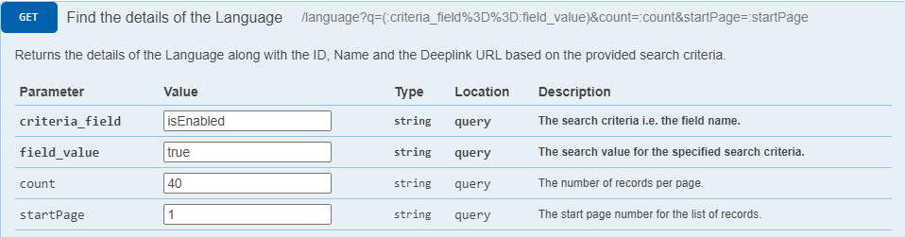
Response: 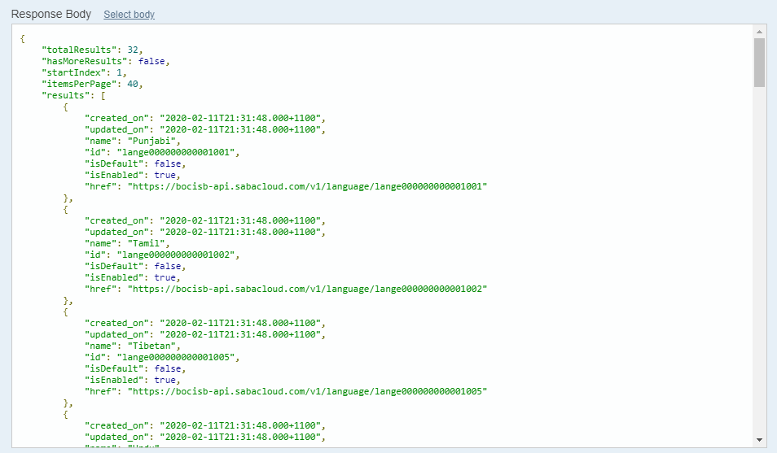

Get all categories
Source API (Get All Categories) /learning/category
Remarks:
Keep call this API until the “hasMoreResults” is false
Request:
Response: 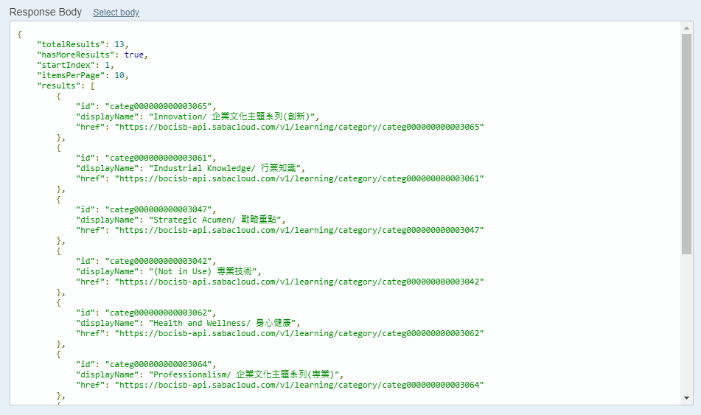

Get the detail of category
Source API (Get Category Details) /learning/category/:categoryId
Parameter | Value
categoryId | categ000000000003065
Remarks:
Just get the record that start with “dummy” in context field
Request: 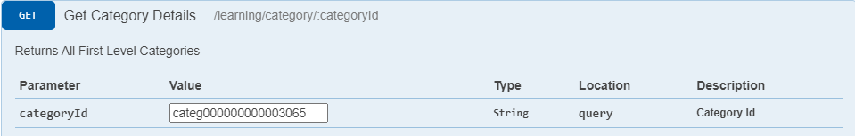
Response: 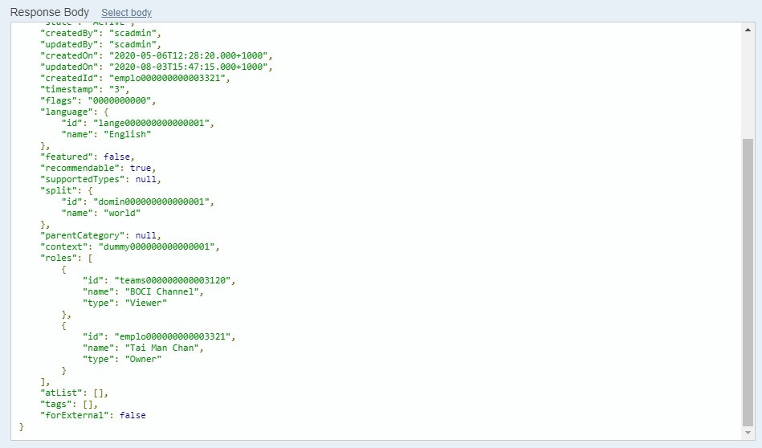

ILT Class Data

Get the details of class
Source API (Get the details of an class) /offering/:offeringId
Parameter | Value
offeringId | class000000000003204
context | admin
Remarks:

Request: 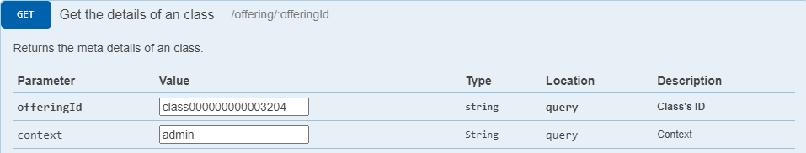
Response: 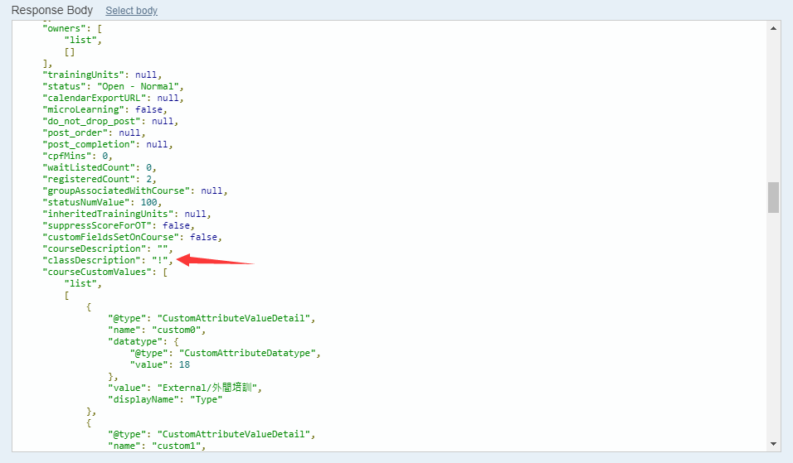

Get all enabled location
Source API (Find the details of the Locations) /location?q=(:criteria_field%3D%3D:field_value)&count=:count&startPage=:startPage
Parameter | Value
criteria_field | enabled
field_value | 1
count | 10
startPage | 1
Remarks:
Keep call this API until the “hasMoreResults” is false
Get all enabled location for selection in classes
Request: 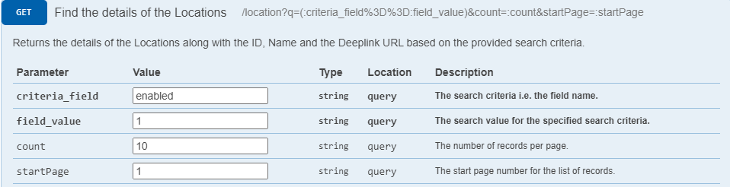
Response: 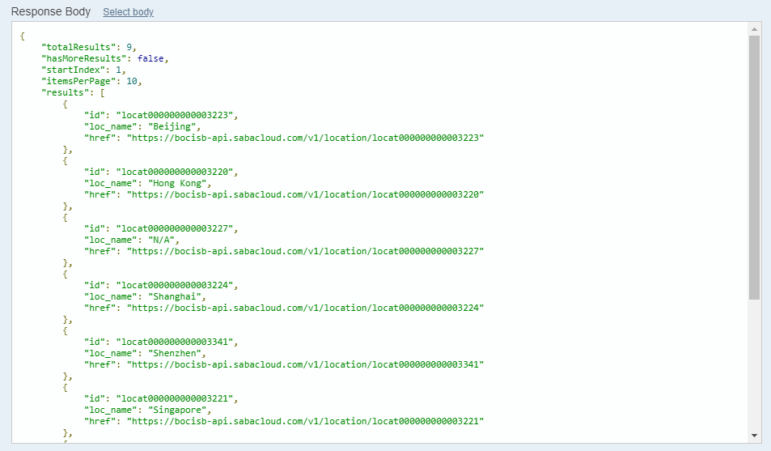

Get all enabled facility
Source API (Find the details of the Facilities) /facility?q=(:criteria_field%3D%3D:field_value)&count=:count&startPage=:startPage
Parameter | Value
criteria_field | enabled
field_value | 0
count | 10
startPage | 1
Remarks:
Field_value: =0 (for enabled), =1 (for disabled)

Request: 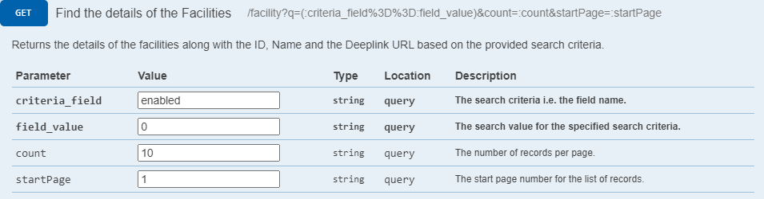
Response: 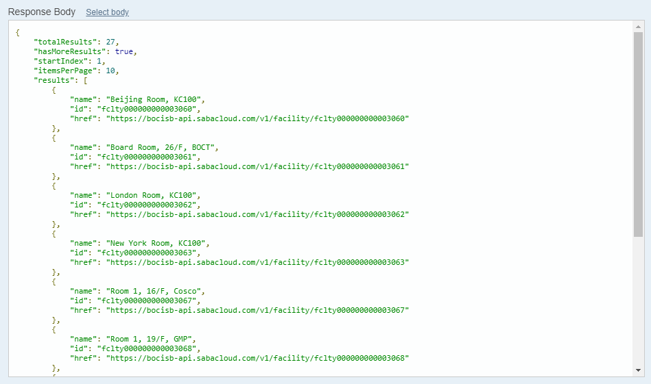

Get all enabled currencies
Source API (Find the details of the currencies) /currency?q=(:criteria_field%3D%3D:field_value)&count=:count&startPage=:startPage
Parameter | Value
criteria_field | active
field_value | 1
count | 10
startPage | 1
Remarks:
Keep call this API until the “hasMoreResults” is false
Request: 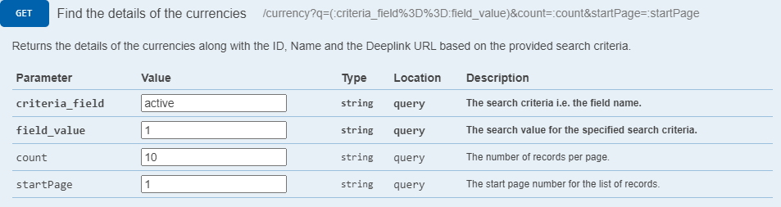
Response: 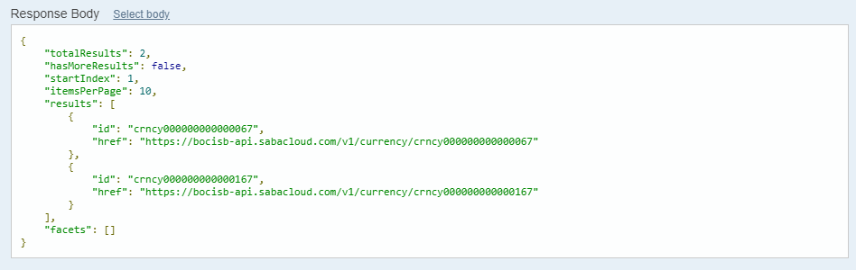

Get the detail of currency
Source API (Get the details of a particular currency) /currency/:id:(:searchFields)
Parameter | Value
id | crncy000000000000067
searchFields
Remarks:

Request: 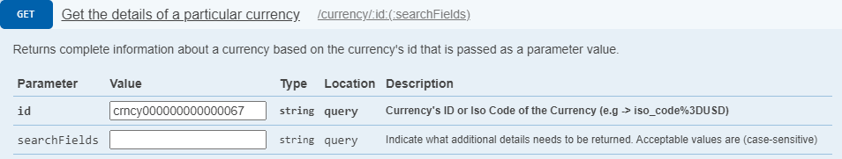
Response: 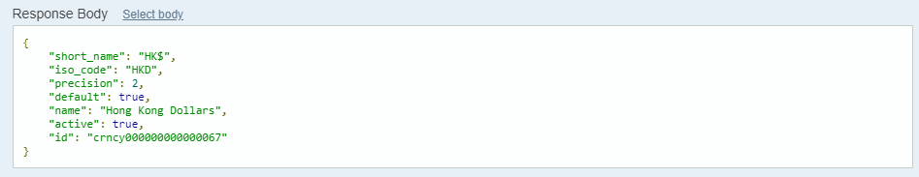

WBT Class Data

Get all WBT class
Source API (Get All classes) /offering?type=:type&count=:count&startPage=:startPage
Parameter | Value
type | web_based
count | 10
startPage | 1
Remarks:
Keep call this API until the “hasMoreResults” is false
Get all WBT class
Request: 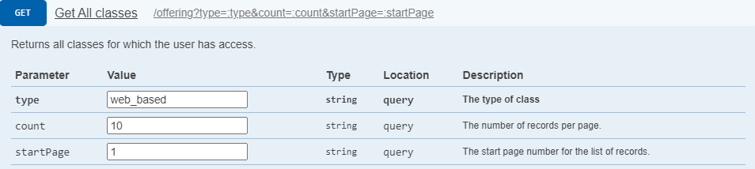
Response: 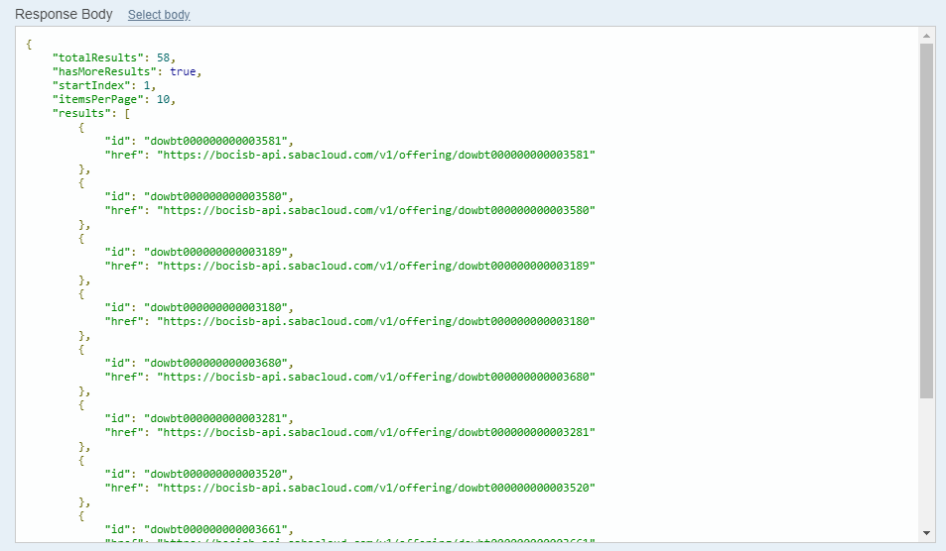

Get the details of class
Source API (Get the details of an class) /offering/:offeringId
Parameter | Value
offeringId | dowbt000000000003581
context | admin
Remarks:

Request: 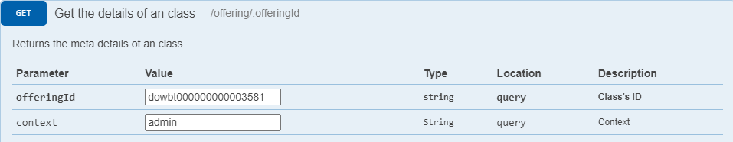
Response: 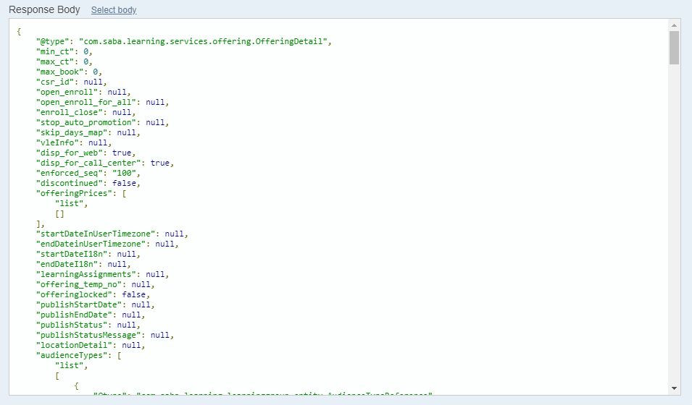

Get all audience types
Source API (Get All AudienceTypes) /audiencetype?count=:count&startPage=:startPage
Parameter | Value
count | 10
startPage | 1
Remarks:
Keep call this API until the “hasMoreResults” is false
Request: 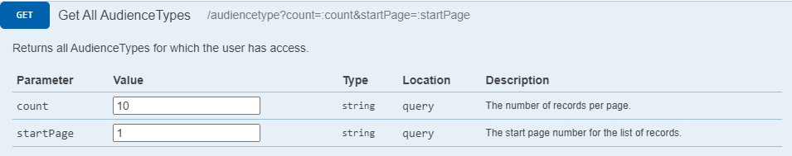
Response: 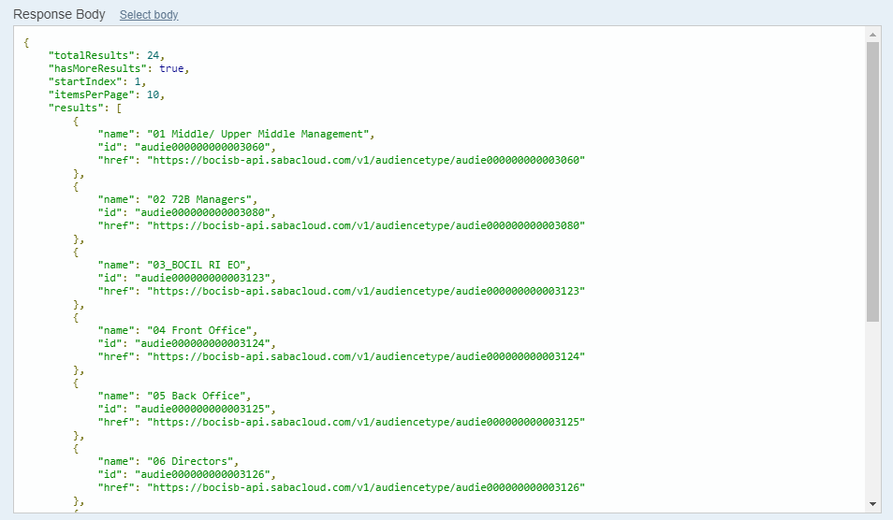

Get all sub audience types
Source API (Get All AudienceTypes) /audiencetype?count=:count&startPage=:startPage
Parameter | Value
count | 10
startPage | 1
Remarks:
Keep call this API until the “hasMoreResults” is false
Request: 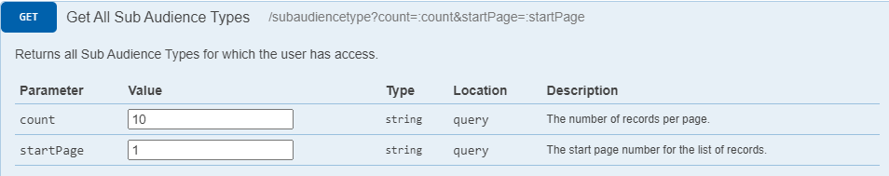
Response: 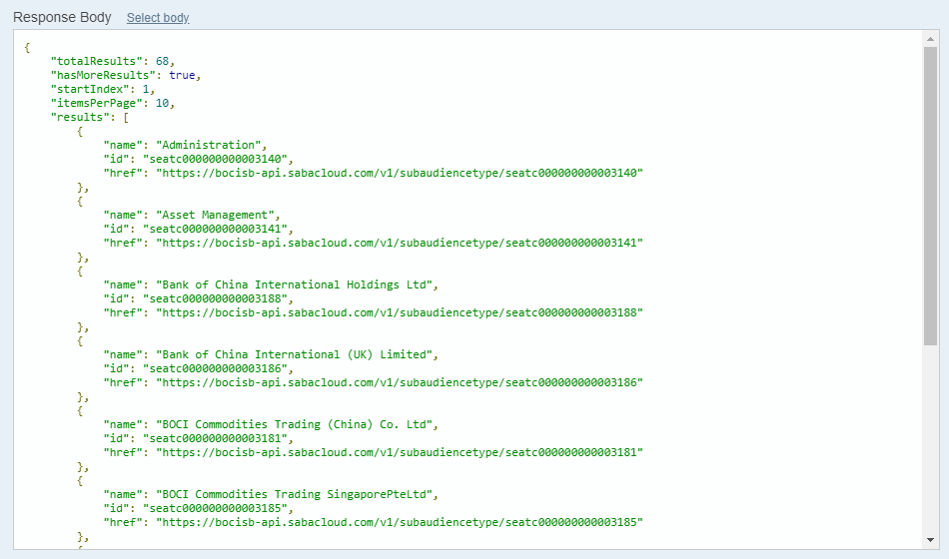

Maintenance in LAS (Course and Class)

Divisional User (“System User”)
To facilitate the process of creating course and class, the form of divisional user (“system user”) will be simpler than the HR user (“super administrator”) version. The form contains the information of course and class as well as some fields will convert to a meaningful question. Below is the list of their relationship.
Form of ILT Class
Field Name | Label on LAS | From | Remark
Course ID |  | Course & Class | Default: Yes
Class ID |  | LMS
Main Tab – Scheduling Details
Start Date |  | LMS
Session Template |  | LMS
Duration |  | LMS | For future use
Location |  | LMS | For future use

Super Admin

Course View – display courses

Course, class creation - create new course and class

Enrolment creation - assign staff to the class

Attendance creation - record attendance of class

Creation in LAS by Excel

Creating and editing course, class, enrolment, and attendance are become possible by uploading excel file to the LAS. There are two types of excel and listed below.

Course, class from HR template

Course sheet
Fields | Excel validation | System validation | Remark
Upload temp course id |  | Check duplicate | For mapping the specified course at class sheet in same excel file
title |  | Required
Domain | Domain List | - Required  - Value is in latest domain list
Abstract |  | Character not more than 1000
Description |  | Character not more than 2000
Create group | True / False
Is sensitive | True / False
Hide score | True / False
Show web 2.0 function | True / False
Can Waive | True / False
Hide classmates | True / False
Target days |  | Is positive integer or blank
Owner | Owner List | Value is in latest domain list | - Multiple value, split by newline  - HR only
Price | Currency List | Value is in latest domain list | - Multiple value, split by newline  - Format Example: HKD10.00, USD15.50  - HR only
Available From |  | Required
Discontinued From |  | larger than available from
Display for call center | True / False
Display for Learner | True / False
Featured | True / False
Type | Type List | Value is in latest Type list
Method1 | Method1 List | Value is in latest Method1 list
Method2 | Method2 List | Value is in latest Method2 list
HO Type (1) | HO Type (1) List | Value is in latest HO Type (1) list
HO Type (2) | HO Type (2) List | Value is in latest HO Type (2) list
CPT |  | Is Number
OPT |  | Is Number
IA CPD |  | Is Number
MPFA CPD |  | Is Number
Entitle for CPT/OPT | YES / NO | Required
Year |  | - Required  - Is 4 digit year
Sub category | Sub category List | Value is in latest Sub category list
Category | Category List | Value is in latest Category list | Multiple value, split by newline
Skill | Skill list | Value is in latest Skill list | Multiple value, split by newline
Language | Language list | Value is in latest language list | Multiple value, split by newline
Notifications | Notifications list | Value is in latest notifications list | Multiple value, split by newline

Class sheet
Fields | Excel validation | System validation | Remark
Course |  | - Required  - Course found | Three cases:  - Upload temp course id  - LAS course number  - LMS course number
type
title
Domain
Abstract
Description
Create group
Is sensitive
Hide score
Show web 2.0 function
Can Waive
Hide classmates
Target days
Owner

Data sheet
Data sheet store all lists of option value for user reference and excel validation.

Data | Remark
Domain | For Course and Class
Owner | For Course
Currency | For Course
Type | From Course Other Information  Hardcode
Method1 | From Course Other Information  Hardcode
Method2 | From Course Other Information  Hardcode
HO Type (1) | From Course Other Information  Hardcode
HO Type (2) | From Course Other Information  Hardcode
Sub Category | From Course Other Information  Hardcode
Category | For Course
Skill | For Course
Language | For Course
Notifications | For Course and Class  Hardcode

Enrolment and Attendance record from HR template
HR attendance template file could be import to LAS and create a temporary attendance record. The following is the fields in Sheet “Attendance”.
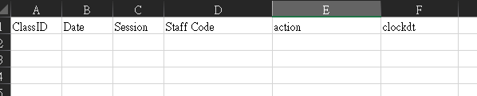
Fields: ClassID, Date, Session, Staff Code, action, clockdt

The following is the table for field mapping of LAS refer to HR template attendance file.
Field | HR Template | Remark
hisid |  | Primary Key generate by System
clockdt | clockdt
action | action
status |  | Hardcoded as “CONFIRM” ^{2A}
sessionid | ClassID, Date, Session^{2B}
learnerid | Staff Code^{1A}
createby |  | Creator^{2C}
clockremark
remarkby

Mapping Logic and Validation

- Mapping of “learnerid”
  - System will identify the staff by checking staff code field in HR attendance file.
  - If the staff is not found, system will mark it down as problem entry and keep run the remaining records.

- Creation of attendance record in temporary table
  - The status of all records will be marked as “CONFIRM”
  - It will show the “sessionid” that contain the same “ClassID”, “Date” and “Session” data.
  - “Createby” field would be filled with the uploader’s staff code

Error Handling
An error handling section will be displayed in upload page which show all problem entry and reject the uploaded file. HR need to check and adjust the specified rows regarding to the problem.

Attendance record from Zoom template
Zoom attendance record could be import to LAS and create a temporary attendance record. HR User should select the session before uploading the Zoom attendance file.
The following is the Zoom attendance file.
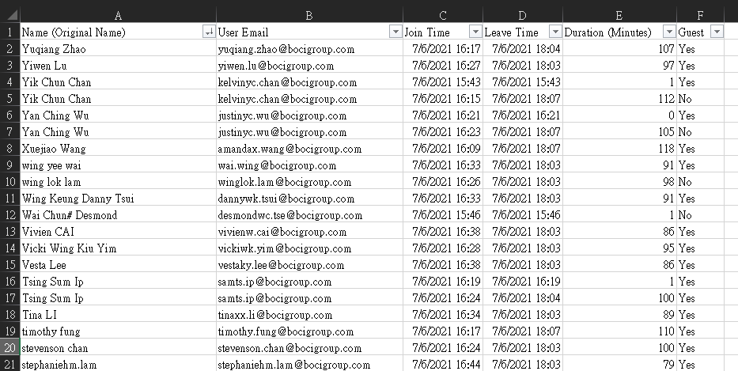

The following is the table for field mapping of LAS refer to Zoom attendance file.
Field | Zoom Template | Remark
hisid |  | Primary Key generate by System
clockdt | Join Time / Leave Time^{2B}
action | Clock in / Clock out ^{2C}
status |  | Hardcoded as “CONFIRM” ^{2D}
sessionid |  | Refer to selected session before uploading
learnerid | User Email^{1A}
createby |  | Creator^{2E}
clockremark
remarkby

Mapping Logic and Validation

- Mapping of “learnerid”
  - System will identify the staff by checking the user email field in Zoom attendance file.
  - If the staff is not found, system will mark it down as problem entry and keep run the remaining records.

- Creation of attendance record in temporary table
  - System will gather all records with same session and same user in Zoom attendance file.
  - If multiple records are found, system will mark the earliest “Join Time” as clock in datetime and the last “Leave Time” as clock out datetime.
  - System split the record into two: clock in record and clock out record.
  - The status of all records will be marked as “CONFIRM”
  - “Createby” field would be filled with the uploader’s staff code

Error Handling
An error handling section will be displayed in upload page which show all problem entry and reject the uploaded file. HR need to check and adjust the specified rows regarding to the problem.

Attendance record from Webex template
Webex attendance record could be import to LAS and create a temporary attendance record. HR User should select the session before uploading the Webex attendance file.
The following is the Webex attendance file.
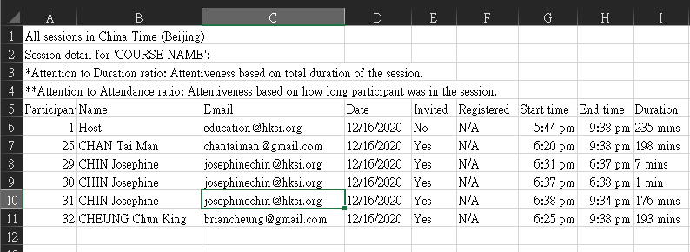
The following is the table for field mapping of LAS refer to Webex attendance file.
Field | Webex Template | Remark
hisid |  | Primary Key generate by System
clockdt | Date + Start Time / End Time^{2B}
action | Clock in / Clock out ^{2C}
status |  | Hardcoded as “CONFIRM” ^{2D}
sessionid |  | Refer to selected session before uploading
learnerid | Email^{1A}
createby |  | Creator^{2E}
clockremark
remarkby

Mapping Logic and Validation

- Mapping of “learnerid”
  - System will identify the staff by checking the email field in Webex attendance file.
  - If the staff is not found, system will mark it down as problem entry and keep run the remaining records.

- Creation of attendance record in temporary table
  - System will gather all records with same session and same user in Webex attendance file.
  - If multiple records are found, system will mark the earliest “Date + Start Time” as clock in datetime and the last “Date + End Time” as clock out datetime.
  - System split the record into two: clock in record and clock out record.
  - The status of all records will be marked as “CONFIRM”
  - “Createby” field would be filled with the uploader’s staff code

Error Handling
An error handling section will be displayed in upload page which show all problem entry and reject the uploaded file. HR need to check and adjust the specified rows regarding to the problem.

Temporary Records Submission and Synchronize to LMS

Fields | Excel validation | System validation | Remark
Course |  | - Required  - Course found | Three cases:  - Upload temp course id  - LAS course number  - LMS course number

