Ref: BOCI/IS/2020 Date: 8 April 2020

Interfacing Specification –
BOCI Learner Attendance System
for
Bank of China International Holdings Limited

Document Profile

Document Description | BOCI Learner Attendance System
Document Ref. No. | BOCI/IS/2020
Prepared by | Mr. Ken YU  IT Director  Hash Tech Pro Limited  Tel : 9125 0399  E-mail : ken@hashtechpro.com
Date of This Release | 8 April 2020

Overview
To make the attendance system works, it requires data transfer between attendance system and Saba system. Below items describe where, how, and what data will be involved.
- Chart of data flow
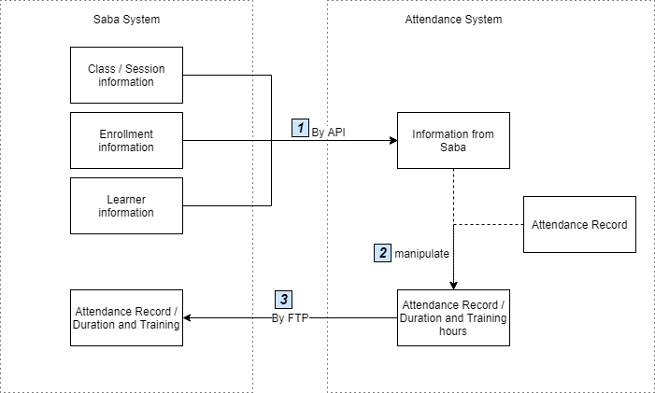
- Class / Session, Enrollment and Learner information will be retrieved by API daily in midnight. System administrator also could sync the data to attendance system manually in backend system. These data will store in Attendance System to maintain the system operation. The details of the implementation are listed at section 1.1 – Retrieve data from Saba.
- After the class end, Attendance System will calculate the duration and training hours of each learner and then manipulate all data (including Class / Session, enrollment, learner information, attendance record, duration and training hours) to save in a CSV file.
- Once system administrator confirmed the data is correct, system will upload the CSV to Saba System by FTP. After upload, Attendance System will trigger Saba system to update their database. The detail of the implementation are listed at section 1.2 – Upload attendance record to Saba system.

- Retrieve data from Saba by API
Class & Session information
Saba API | Saba Field | Description
 | offeringId | classId
 | name | className
 | startDate.dateInUserTimeZone  startDate.timeInUserTimeZone | datetime_start
 | endDate.dateInUserTimeZone  endDate.timeInUserTimeZone | datetime_end

Enrollment Information
Saba API | Saba Field | Description
 | Student id | Learner id
 | Student email | Learner email

Learner Information
Saba API | Saba Field | Description
 | fname | Learner firstname
 | lname | Leaner lastname
 | custom3 | Learner division
 | custom4 | Learner staffCode
 | displayName | Learner profile picture

- Upload attendance record to Saba by SFTP

CSV format
Parameter | Value
classid | Class id (from Saba)
classname | Class name (from Saba)
session_startdatetimeInUserTimeZone | Session start datetime (format: YYYY-MM-DD HH:MM:SS) (from Saba)
session_enddatetimeInUserTimeZone | Session end datetime (format: YYYY-MM-DD HH:MM:SS) (from Saba)
staffid | Staff id (from Saba)
staffcode | Staff code (from Saba)
email | Staff email (from Saba)
division | Staff division (from Saba)
staffname | Staff name (from Saba)
clockin | Clock in datetime
clockout | Clock out datetime
duration_hours | Time different of clock in and clock out datetime in hours
duration_minutes | Time different of clock in and clock out datetime in minutes
trainingtime_hours | Time different of clock in and clock out datetime in hours, not larger than the session duration
trainingtime_minutes | Time different of clock in and clock out datetime in minutes, not larger than the session duration

- Get learner id from Enrollment QR code by API
Enrollment QR code contains the registration id, Saba enrollment API must be called to get the learner id for further action (e.g. take attendance). The details of the implementation would be found at section 1.1.2 – Enrollment QR Code.
- Host (& Port) of the Saba API
UAT
LIVE

- SFTP account
IGS permit IP 202.74.40.104 to access the Saba SFTP (sydsftp.sabahosted.com) for BOCI Production and QA Environment.
UAT | Hostname: sydsftp.sabahosted.com  Username: BOC_International_Holdings  Password: (To be provide later)  Port: 22222
LIVE | Hostname: sydsftp.sabahosted.com  Username: BOC_International_Holdings  Password: (To be provide later)  Port: 22222

Retrieve data from Saba

Cron Job
A Cron job will be run at everyday midnight (1 hours after HR sync job run from Saba) to retrieve class, session, learner and enrollment data from Saba. Below is the list of APIs which will call in the system.

Get Certificate
Retrieve the certificate token for all Saba API.
Source API (Get Certificate) /login
Parameter | Value
user | KEN@HASHTECHPRO.COM
Request:
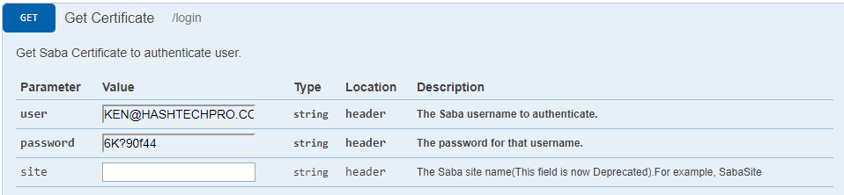
Response: 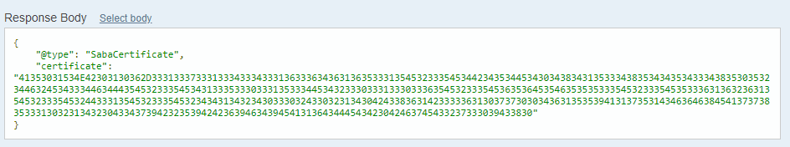

Get All Classes and Sessions
Step 1) Get All Classes
Source API (Get All Classes) /offering?type=:type&count=:count&startPage=:startPage
Parameter | Value
type | instructor_led
count | 30
startPage | 1
Remarks: Keep call this API until the “hasMoreResults” is false
Request: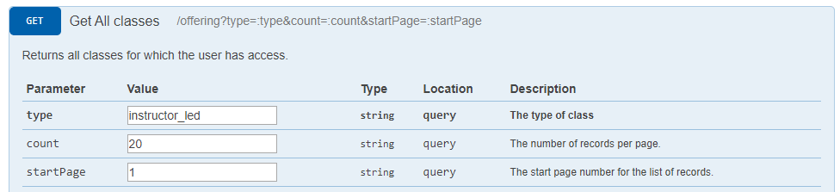
Response: 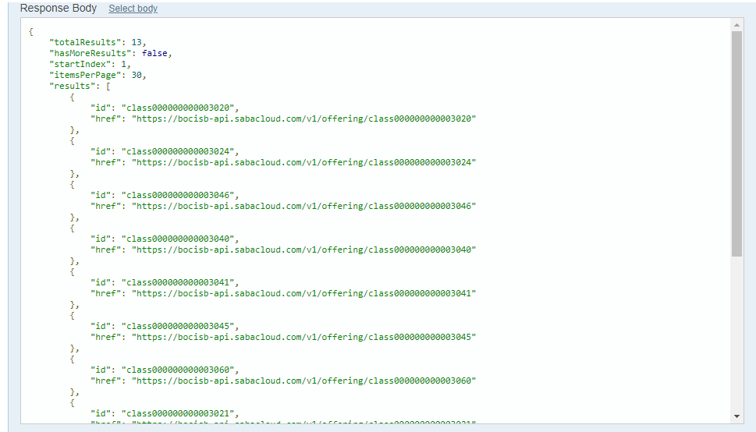

Step 2) Get Classes Details
Source API (Get the details of an class) /offering/:offeringId
Parameter | Value
offeringId | class000000000003020
context | admin
Remarks: Get the class name only
Request: 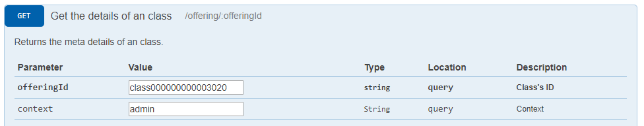
Response: 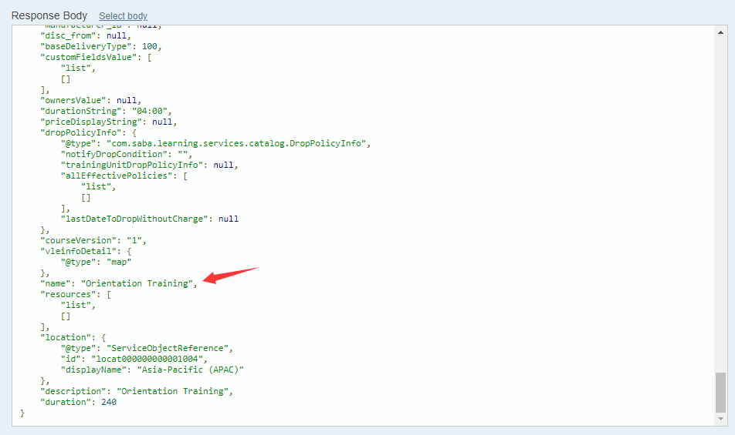

Step 3) Get Sessions Details
Source API (Retrieve all the sessions of an Offering) /offering/:offeringId/session
Parameter | Value
offeringId | class000000000003020
Remarks: get all unexpired sessions date and time.
For start date: sessionsInUserTimezone.list.startDate.dateInUserTimeZone
For start time: sessionsInUserTimezone.list.startDate.timeInUserTimeZone
For end date: sessionsInUserTimezone.list.endDate.dateInUserTimeZone
For end time: sessionsInUserTimezone.list.endDate.timeInUserTimeZone
Request: 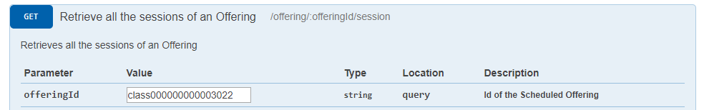
Response: 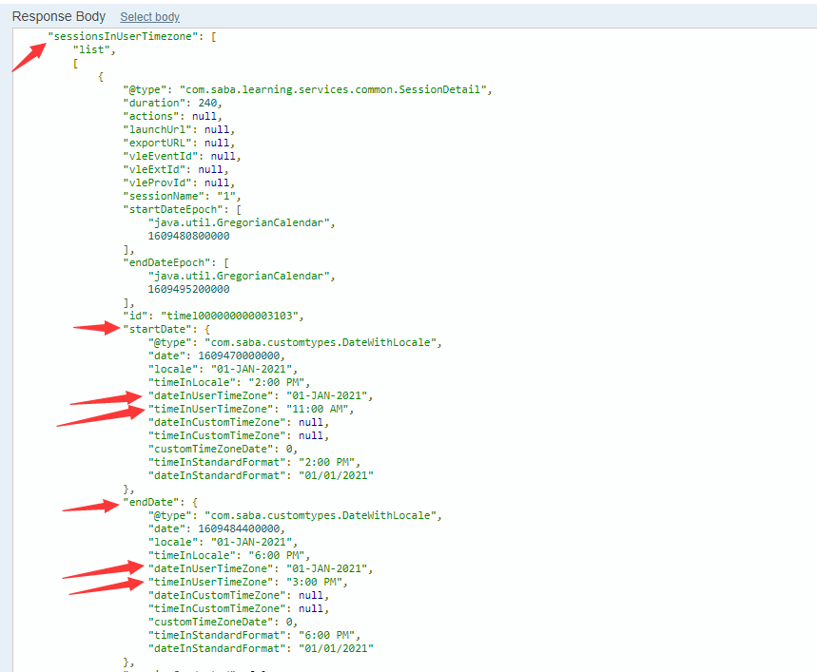
Destination:
Table “Session”
From | To Table Field
offeringId (step 1) | classId
name (step 2) | className
startDate.dateInUserTimeZone  startDate.timeInUserTimeZone | datetime_start
endDate.dateInUserTimeZone  endDate.timeInUserTimeZone | datetime_end

Get All Enrollment
Source API (Search enrollments based on given criteria) /learning/enroll/search?q=(:searchCriteria)&count=:count&startPage=:startPage&includeDetails=:includeDetails
Parameter | Value
searchCriteria | class_id==class000000000003020
count | 30
startPage | 1
includeDetails | true
Remarks: Keep call this API until the “hasMoreResults” is false
Request: 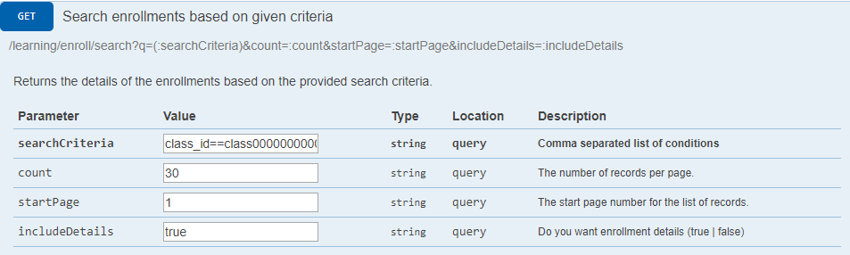
Response: 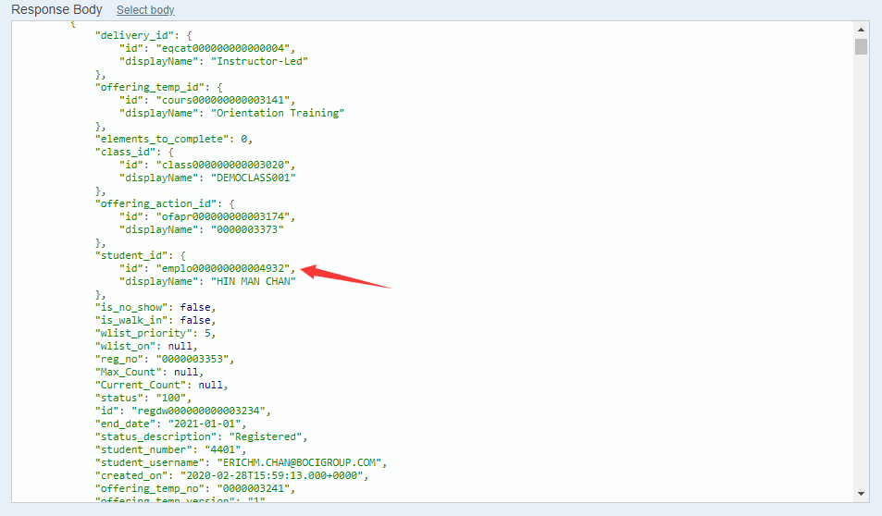
Destination:
Table “Attendance”
From | To Table Field
student_id | LearnerId
Student_email | email

Get All Learner and details
Step 1) Get All Learner
Source API (Get All Persons (Internal/External)) /people?type=:type&count=:count&startPage=:startPage
Parameter | Value
type | internal
count | 30
startPage | 1
Remarks: Keep call this API until the “hasMoreResults” is false
Request: 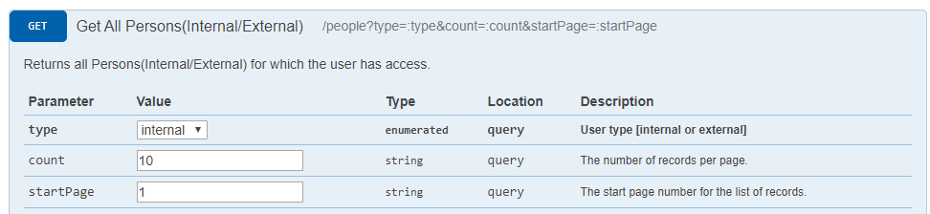
Response: 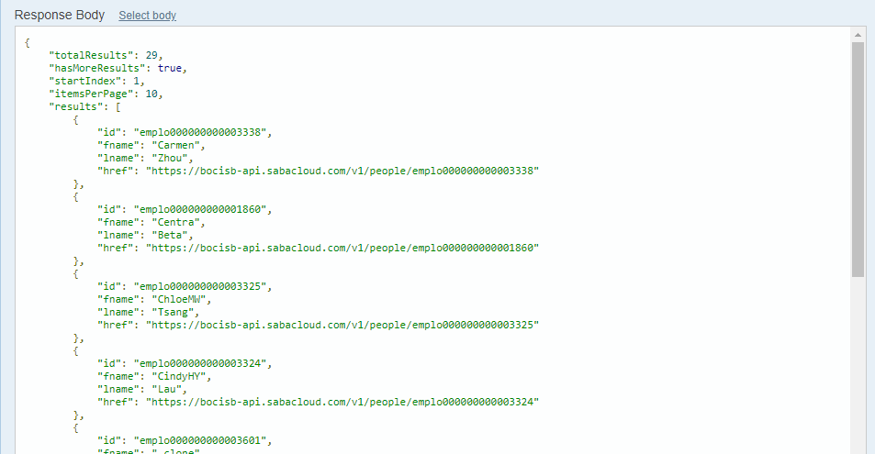

Step 2) Get Learner’s BOCI staff code / division / staff name
Source API (Find profile information) /people?type=:type&f=(:searchFields)&q=(:query)&count=:count&startPage=:startPage
Parameter | Value
type | internal
searchFields | custom3,custom4,fname,lname
query | id==emplo000000000003321
count | 10
startPage | 1
Remarks: get BOCI staff code and Learner picture (only get picture when system don’t have)
Request: 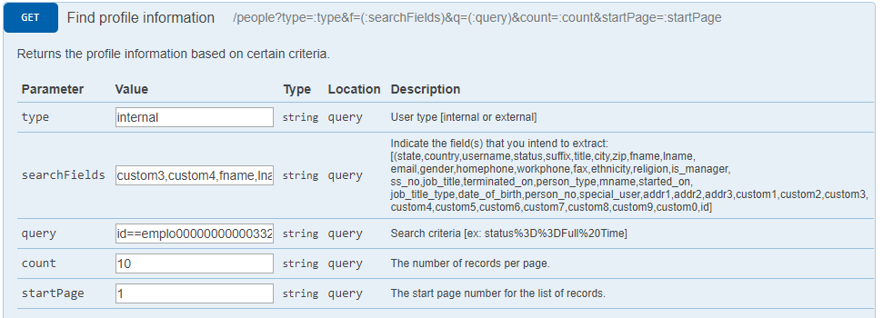
Response: 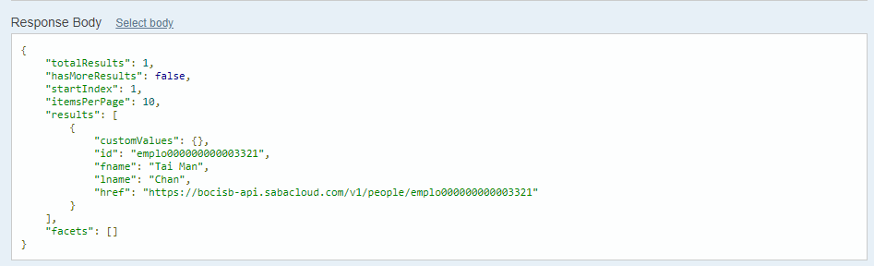
Step 3) Get Learner’s profile image
Source API (GET Profile Pic URL)
/common/profile/:personId/profilePicURL
Parameter | Value
psersonId | emplo000000000005698
Remarks: get BOCI staff code and Learner picture (only get picture when system don’t have)
Request: 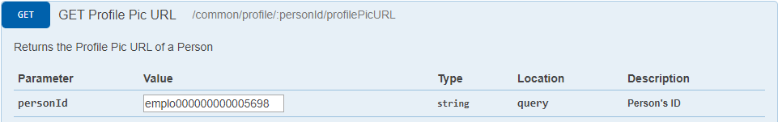
Response: 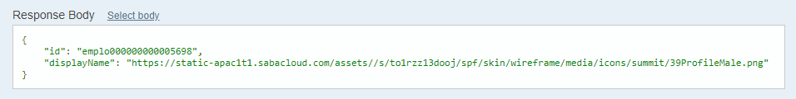
Destination:
Table “Learner”
From | To Table Field
fname(Step 1) | firstname
lname(Step 1) | lastname
custom3(Step 2) | division
custom4(Step 2) | staffCode
displayName(Step 3) | Attachment table

Enrollment QR code
The QR code will provide personPictureURL, registrationId. Use registrationId to call API retrieving the learnerId.
Source API (Get the details of an enrollment) /enrollments/:id/sections::sections
Parameter | Value
id | regdw000000000003183
sections | regdetail
Remarks: get learnerId only.
Request: 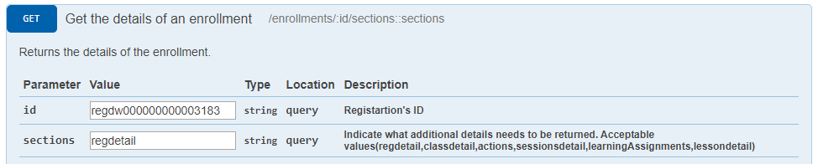
Response: 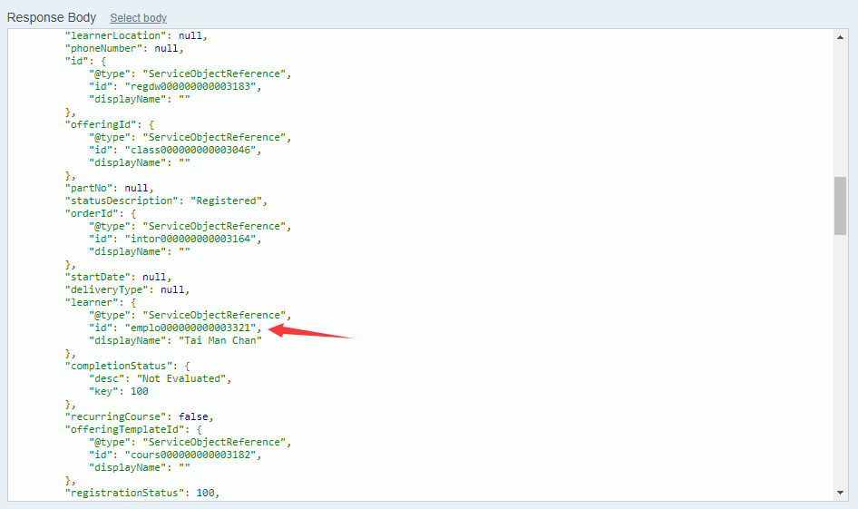

Learner QR code
The QR code will provide learner name(fn), learner id(id) and profile picture. Use learner id find the enrollment information in attendance system.

Upload attendance record to Saba System
After the class / session end, System administrator can upload the attendance record to Saba.
Synchronize step:
- System administrator check the correctness of the attendance record. If okay, they select the record that want to upload and press “Sync selected” button.
- Attendance system will generate a csv and upload to Saba System.

CSV format
Parameter | Value
classid | class id from Saba
session_startdatetimeInUserTimeZone | Session start datetime (format: YYYY-MM-DD HH:MM:SS)
session_enddatetimeInUserTimeZone | Session end datetime (format: YYYY-MM-DD HH:MM:SS)
clock in | Clock in datetime
clock out | Clock out datetime
duration_hours | Time different of clock in and clock out datetime in hours
duration_minutes | Time different of clock in and clock out datetime in minutes
trainingtime_hours | Time different of clock in and clock out datetime in hours, not larger than the session duration
trainingtime_minutes | Time different of clock in and clock out datetime in minutes, not larger than the session duration

