Ref: BOCI/FRS/2020 Date: 18 Mar 2020

Functional Specification –
BOCI Learner Attendance System
for
Bank of China International Holdings Limited

Document Profile

Document Description | BOCI Learner Attendance System
Document Ref. No. | BOCI/FRS/2020
Prepared by | Mr. Ken YU  IT Director  HashTech Pro Limited  Tel : 9125 0399  E-mail : ken@hashtechpro.com
Date of This Release | 24 Mar 2020

Table of Contents
Document Profile i
Table of Contents ii
1 Scope 3
1.1 Frontend Features (Android Mobile App) 3
1.2 Backend Features 3
2 User Flow 4
3 Frontend System Flow 5
4 Manual of Backend 6
5 Frontend Feature 9
5.1 Authentication 9
5.2 Attendance 10
5.3 Language 13
6 Backend Features 14
6.1 Authentication 14
6.2 User 15
6.3 System Log 16
6.4 Class 17
6.5 Attendance 19
6.6 Interfacing 20
7 Database Design 21
8 Interfacing 21
8.1 Retrieve data from Saba 21
8.2 Sync attendance record to Saba 30
9 System Security 31
I. Appendix 32

Scope
The following mentioned module and features will be involved in this project.

Frontend Features (Android Mobile App)
Module | Features
Authentication | User authentication
Attendance | Date / Class / Session List
Attendance | Identify learner by QR Code Scanner / Staff code
Attendance | Show Learner Information
Attendance | Clock in / out
Attendance | Temporary attendance list
Language | Switch language (Simplified Chinese, English)

Backend Features
Module | Features
Authentication | User authentication with BOCI Password Policy
Authentication | Forgot password
User | Administrator List (Search / Create / Update / Delete)
User | Check password expiry
Learner | Learner List (Search, update profile picture)
System Log | System Log (Search)
Class | Class List (Search)
Class | Export session attendance info to Excel
Class | Class / Session attendance Log
Attendance | Attendance List (Search)
Attendance | Export selected attendance record to excel
Attendance | Edit blank and incorrect clock in / out time
Interfacing | Sync selected attendance record to Saba
Interfacing | Cron job to retrieve data from Saba
Interfacing / Class | Manual sync to retrieve data by class from Saba

User Flow
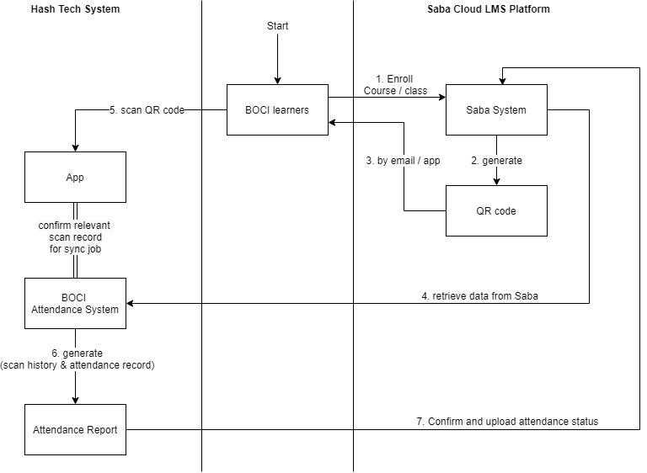
- BOCI Learners enroll themselves to a course/ class on Saba Cloud LMS Platform.
- Saba Cloud LMS Platform (“Saba System”) will generate a QR code.
- BOCI Learners receive the QR code by email / app.
- Hash Tech System retrieve necessary data from Saba.
- When the class begins, System administrator can select class for attendance taking in the Mobile App. System Administrator can use Mobile app to scan the QR code and assist learner to clock in and out (“attendance record).
- When the class completed, System Administrator can review the attendance record for the selected class and confirm the relevant scan record for synchronizing the relevant attendance record from Mobile App to the master Attendance System under “Attendance List”. All scan histories (including irrelevant scan history) shall also synchronize from Mobile App to the master Attendance System under “Log” which includes all scan history and attendance record from Mobile App Database under “Class List”.
- System generates an attendance report for all classes. System Administrator can amend the attendance record (for special case indicated) and confirm the attendance status. The confirmed record will upload to Saba Cloud LMS Platform.

Frontend System Flow
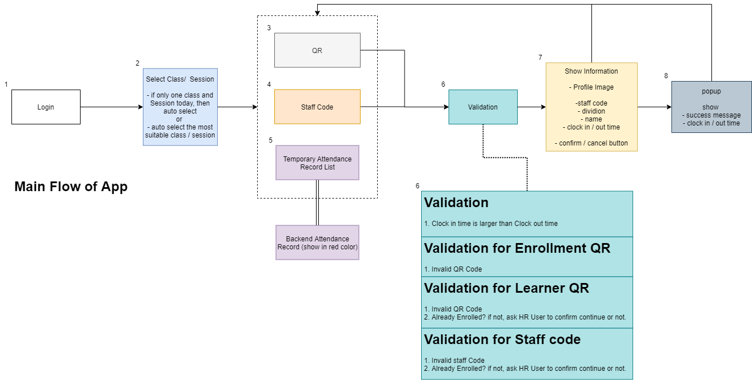
- System Administrator login to the mobile app through the login page. (prototype p.1)
- Select the required class and session. (prototype p.2)
- QR code scanner page with class & session information will be shown by default (prototype p.3, 4)
- User can change to use staff code to identify the learner. (prototype p.8)
- All QR code scan history (keep as temporary attendance record in master Attendance System instantly) will be shown. System Administrator can confirm or delete the data here. (prototype p.11)
- System will do a validation by checking the QR code, Staff code and Clock In/Out time. If invalid, an error popup will be shown. (prototype p.6, 7, 10)
- User profile and clock in / out information will be shown for system administrator to check. (prototype p.5, 9)
- Pop-up with a success message once the confirm button clicked. (prototype p.12) And it will back to QR code scanner page. (prototype p.3, 4)
Frontend Prototype V3: https://xd.adobe.com/view/0ecec4d7-bb7c-4553-56f6-ca595209de10-78ff/

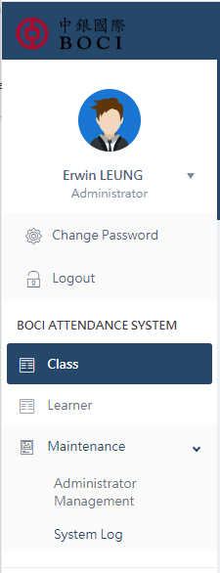
Manual of Backend
Backend Manual Structure
- Under User Profile
  - Change Password
  - Logout
- Under BOCI attendance system
  - Class
  - Learner
  - Maintenance
    - Administrator Management
    - System Log

Under User Profile:
- Change Password: a popup for user change their system login password
- Logout: Sign out (System will timeout in 15 minutes automatically)

Under BOCI attendance system:
- Class - Class and Session list:
    - Search Class by Name
    - Allow to sort by Class ID/Class Name/Date/Session/All data Sync to Saba
    - Go to Session Attendance list by clicking “Attendance”
    - Download all attendance record (relevant scan record in Mobile App picked by System Administrator) of the session by clicking “Excel”
    - Go to QR code scan history to review all records by clicking “Log”
    - Manually update class data by clicking “Update class data”.
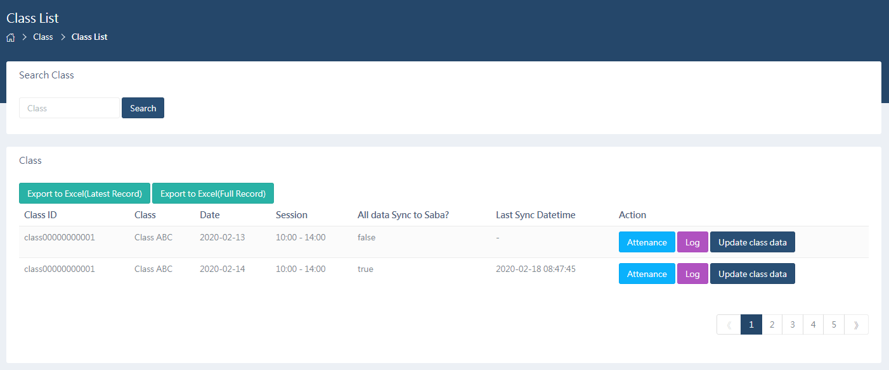
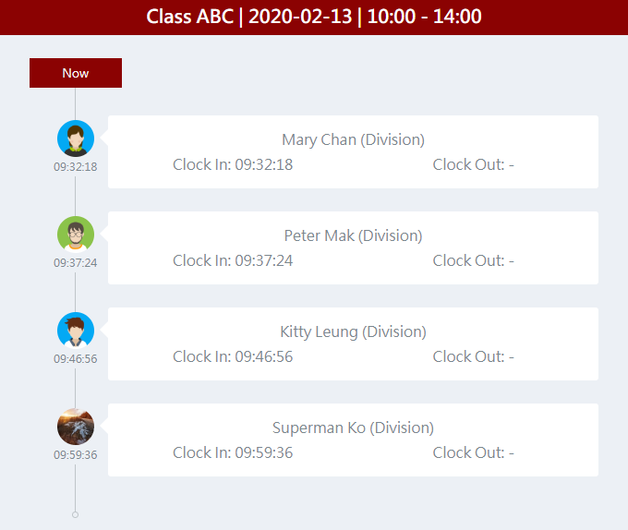
  - Attendance list:
- Search Attendance record by “Enrolled” or “Already Sync” Status
- Confirm the temporary record by clicking “Selected Status to Confirmed”
- Export the attendance record by clicking “Export selected to Excel”
- Sync the attendance record by clicking “Sync Selected”
- Edit Clock in or Clock out time by clicking “Edit”
- System administrator may record down as many attendance records via the mobile app and sync to backend system as needed. By default, the backend “Attendance List” will show the most suitable record in the attendance list. System administrator can press “Expand” to show all records for checking.
  - Most suitable record (clock-in): first clock-in record
  - Most suitable record (clock-out): last clock-out record
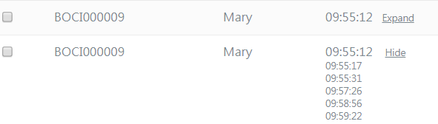
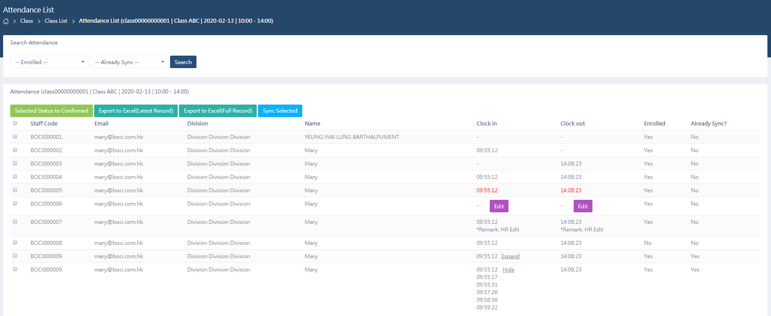
- Learner – Learner List:
- Search Learner by Staff Code, First Name, Last Name, Division and Email
- Edit Learner’s profile picture by clicking “Edit Profile Picture”
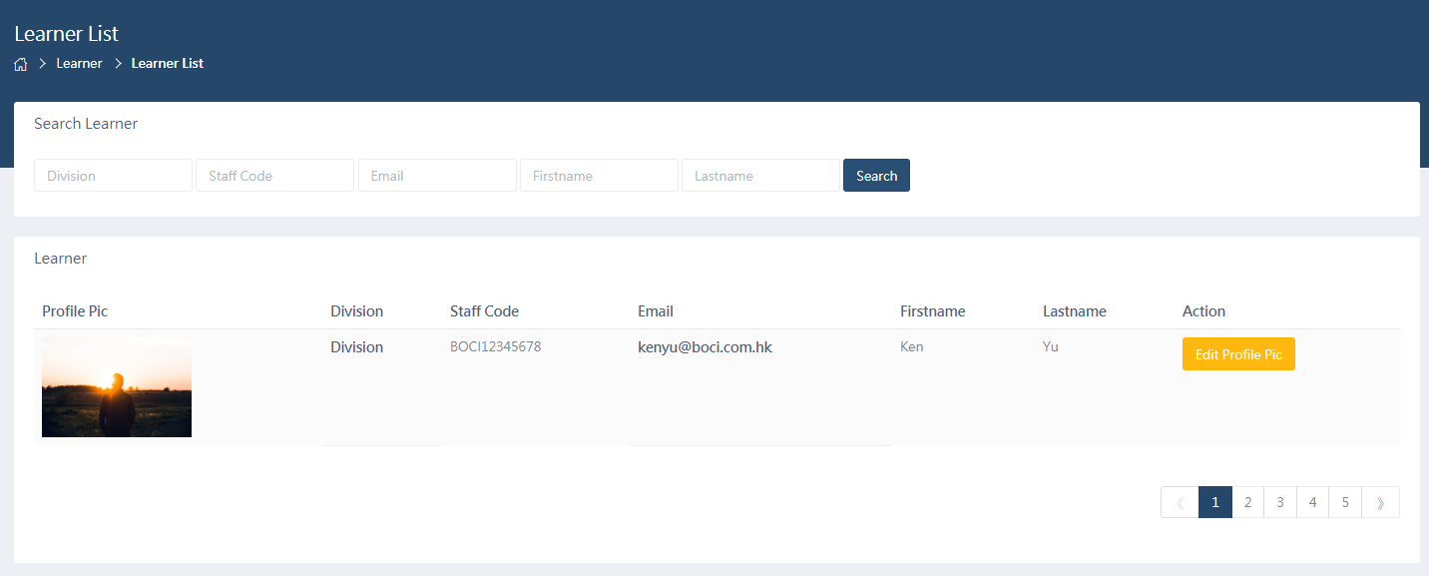
- Maintenance
  - Administrator Management
- Search Administrator by Nickname(Optional), Username (=email address), Staff Code, location, device ID or status
- Create, modify and delete administrator
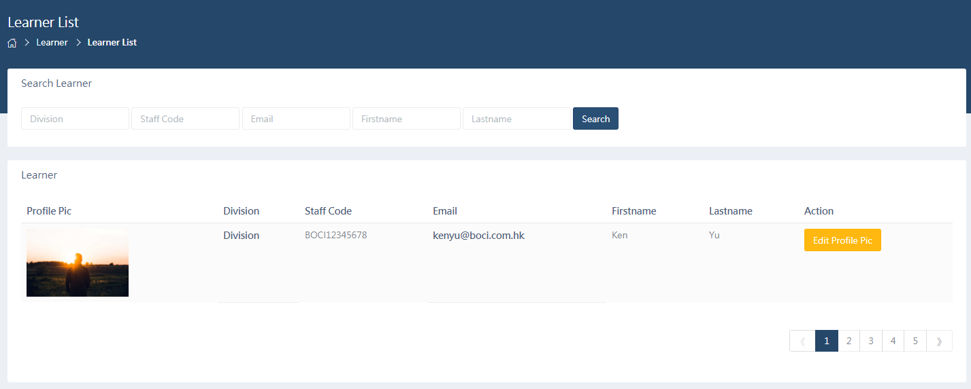
  - System Log
- Search system log by System administrator, log type, datetime or IP address
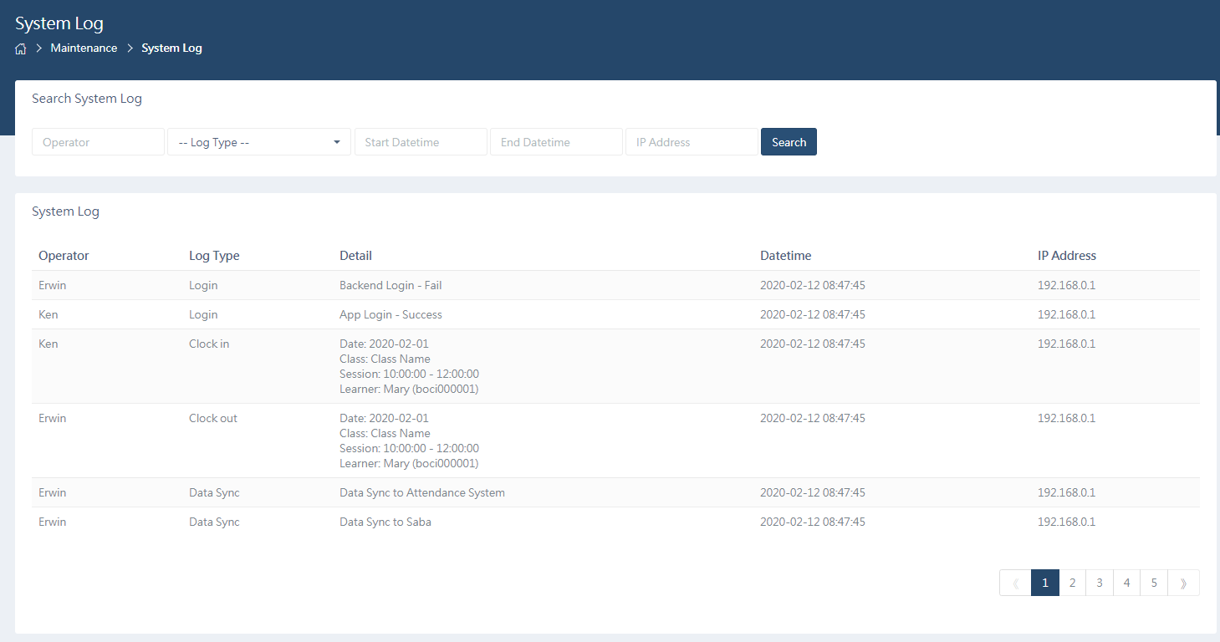

Frontend Feature

Authentication

User Authentication
Simple Login function.
- All account could be maintained by System Backend
- When login, if the password is about to be expired (before 15 days and expired date), it will notify user by email (cc: LnD@bocigroup.com) to change password via backend
- If the password is expired, account status will become “Expired”. For expired account, they must login to backend themselves to modify their password.
- Not allow to login if the account status is “Inactive”, “Expired” and the Device ID is wrong.

Attendance

Date List
The Classes Date must be today. No selection is allowed.
List Columns
Fields | Description
上課日期 | Classes Date

Class List
Class list shows the classes of today. It will be auto select class if today only have one class.
List Columns
Fields | Description
課程名稱 | Classes name

Session List
Session list shows the sessions of selected class. It will be auto select session if today only have one session. Or it will auto select the most suitable session based on the session start time.
List Columns
Fields | Description
課程時間 | Sessions time

Identify learner by QR Code Scanner / Staff Code
There are three methods (attendance entry/scan methods) for HR user to identify the BOCI learner.
- By Saba Enrollment QR code
- By Saba Learner QR code
- By BOCI staff code
While System administrator selected class and session, press the confirm button and then it will direct to the QR code scanner page.
System administrator is able to change the clock in / out mode by the button at the top of page.
Background color will change to red when clock in mode while change to green when clock out mode.
System administrator is able to change the attendance entry method by the button at the bottom of page.
While the QR code scanner detected and read the QR code, it will have “bit” sound to notify user.
Once the QR code is scanned or inputted the staff code, system will conduct a validation against the user profile and enrollment record. If it’s valid, a popup window will be shown with learner information and profile picture for HR user to clarify the learner identity.

Validation Logics:
- Enrollment QR code
    - Valid – the QR code is a Saba Enrollment QR code
    - Invalid – the QR code is not a Saba Enrollment QR code
  - Learner QR code
    - Valid – the QR code is a Saba Learner QR code and Learner has enrolled to the session.
    - Invalid – (1) the QR code is not a Saba Learner QR code, and/or
(2) Learner not enrolled – popup to ask still to do the clock in / out?
- Staff code
    - Valid – Staff code is in Saba Learner List and Learner is enrolled.
    - Invalid – (1) Staff code not found, and/or
(2) Learner not enrolled – popup to ask still to do the clock in / out?
- Both
    - Valid – clock in time is smaller than clock out time and no duplicated clock in/out record.
Invalid – (1) Clock in time is larger than Clock out time – popup to ask still to do the clock in / out; and/or
(2) Already clock in / out – popup to ask to keep which the clock in / out record?

Saba Enrollment QR code Data Sample:
{
personPictureURL: “https://xxx”,
registrationId: “regdw000000013”,
name: “Mary”
}

Saba Learner QR code Data Sample:
{
fn: “Ken Yu”,
id: “emplo000000000003340”,
iu: “https://xxx”
}

Show Learner Information
Learner information and clock in / out time will be shown for checking.
Learner information
Fields | Description
Profile image相片 | Learner profile image
員工名稱 | Learner name (Last Name, First Name)
員工編號 | Learner staff code
工作部門 | Learner division

Clock in / out
Press the confirm button to save the clock in / out data of corresponding learner to the temporary attendance list instantly.

Duplicate Clock in / out record handling logic:
Get the first clock in datetime as a final clock in datetime.
Get the last clock out datetime as a final clock out datetime.

Remarks: Each scan action will log down the record and will be shown in system log.
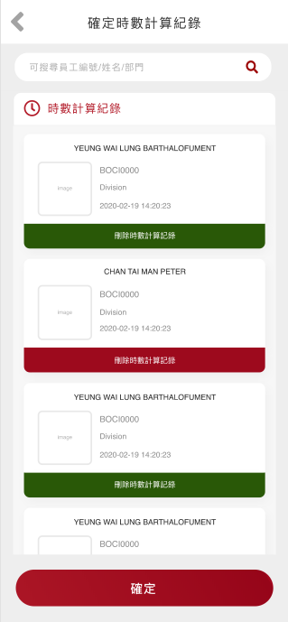

Temporary Attendance list
All clock in / out data will be shown in frontend attendance record. In backend, the color of the clock in / out time of the attendance record will be displayed in backend “Attendance List” as red. It will change to black color once confirmed the record.
Administrator could search the record by staff code, staff name or division name and delete inappropriate independent record. They also could confirm all record to clear the list.

Language

Switch Language
Switch the display language between Simplified Chinese and English. The language button located on the right of the navigation bar.

Backend Features

Authentication

User Authentication with BOCI Password Policy
BOCI systems should enforce Password under the following recommendation:
Password Expiry | Regular password changes every three months, at a minimum
Password History | An appropriate and retainable user password history.  New user password selection being checked against their previous last 2 password histories and rejected if there is a match
Minimum Password Length | Password consisting of at least eight characters in length and composed of letters, digits, and punctuation characters (depending on the system concerned)
Maximum Fail attempt | Failed attempts being limited to six or the user account will be locked out (If possible, warning messages about fail attempts should be displayed prior to successful logon and sent to help-desk administrator)
Freeze idle account | Accounts idled for over three months being locked, if possible
Password Complexity | Alphanumeric (Combined with characters and digits)
Reset Account Lockout Count | 1440 minutes

- When login, if the password is about to be expired (before 15 days and expired date), it will notify user by email (cc: LnD@bocigroup.com) to change password.
- If the password is expired, account status will become “Expired” and request user to change password immediately, otherwise system will not allow to login.
- Not allow to login if the account status is “Inactive”.

Forgot password
Allow administrator to restore their password via backend.
- Enter the username (email) in forgot password page.
- System will send a password restore link to administrator through email
- Administrator enter the new password and confirm password to change it.

User

Administrator List
System administrator can search, create, update, delete system administrator. System Administrator can log in to the backend system and the mobile app.
List Columns
Fields | Description
Nickname | Nickname
Username | Username (must be an email)
Staff Code | Staff Code
Device ID | Device ID of the account
Location | Location of the User from Saba System (HK, UK, US)
Status | Administrator Status  - Active  - Inactive  - Expired
Create Datetime | Create Datetime
Modify Datetime | Modify Datetime
Search Columns
Fields | Description
Nickname | Nickname
Username | Username
Staff Code | Staff Code
Device ID | Device ID
Location | Location of the User from Saba System (HK, UK, US)
Status | Administrator Status  - Active  - Inactive  - Expired
Create Columns
Fields | Description
Nickname | Nickname
Username | Username
Staff Code | Staff Code
Password | Password
Device ID | Device ID of the account
Location | Location of the User from Saba System (HK, UK, US)
 | Administrator Status will auto set to “Expired”
Modify Columns
Fields | Description
Nickname | Nickname
Username | Username (email)
Staff Code | Staff Code
Device ID | Device ID
Location | Location of the User from Saba System (HK, UK, US)
Status | Administrator Status  - Active  - Inactive  - Expired
Login ID | Email Address used for Login to Frontend Mobile App and Backend System
Password | Login Password

Check password expiry
A cron job to check the expiry date of all administrator to find out which is nearly (before 15 days and expired date) and already expired daily. If found, then system will send a notification email to ask administrator to change the password.

Learner List
Learner will be shown. Administrator able to update the learner profile picture here.
List Columns
Fields | Description
Profile Pic | Staff profile picture
Staff Code | BOCI staff code
Firstname | Firstname
Lastname | Lastname
Division | Division
Email | Email Address
Search Columns
Fields | Description
Division | Division
Staff Code | BOCI staff code
Firstname | Firstname
Lastname | Lastname
Email | Email Address

System Log

System Log
System log will be shown.
List Columns
Fields | Description
Admin name | Name of System administrator
Staff Code | Staff Code of Administrator
Log Type | Log type  - Account (login, expiry, reset)  - Clock in  - Clock out  - Data Sync
Detail | Log Description
Datetime | System log datetime
IP Address | IP Address
Search Columns
Fields | Description
Operator | Operator
Log Type | Log type  - Account  - Clock in  - Clock out  - Data Sync
Start Datetime | System datetime from
End Datetime | System datetime to
IP Address | IP Address

Class

Class List
All class / session will be shown.
List Columns
Fields | Description
Class ID | Class ID from Saba
Class | Class name from Saba
Date | Date of the Class from Saba
Session | Session of the Class from Saba
All data Sync to Saba? | Is whole session attendance record sync to Saba?
Last Sync Datetime | Last Sync Datetime
Search Columns
Fields | Description
Class | Class name from Saba

Export session attendance info to Excel
Administrator can export whole session attendance record (with latest record or full record) at class list.
File name format: attendance.xls
Export Columns
Fields | Description
Class ID | Class id from Saba
Class name | Class name
Date | Date of the class
Session Start time | Start time of session
Session End time | End time of session
Staff Code | BOCI staff code
Email | Email
Division | Division
Staff Name | Staff Name
Clock in | Clock in datetime
Clock out | Clock out datetime
Duration | Attend duration
Training Time | Class / Session training time

Class / Session attendance Log
A page for learner to check their attendance record after clock in / out. Administrator could open it at the class list by clicking “Log”
Header Columns
Fields | Description
Class Name | Class Name
Date | Class / Session Date
Session time | Session Period in time
Attendance Columns
Fields | Description
Log time | Record time
Image | Profile image
Name | Learner Name
Division | Division
Clock in | Clock in time
Clock out | Clock out time

Attendance

Attendance List
All Attendance record of class / session will be shown.
For those temporary attendance record, the clock in / out time will be shown in red color. When system administrator confirms the attendance record (from backend or mobile app), it will change to black color.

Search Columns
Fields | Description
Staff Code | BOCI staff code
Enrolled | Is it enrolled in Saba?
Already Sync | The attendance record is already sync to Saba?
List Columns
Fields | Description
Staff Code | BOCI staff code
Email | Email
Division | Division
Name | Staff Name
Clock in | Clock in datetime
Clock out | Clock out datetime
Enrolled | Is the Learner enrolled the class in Saba?
Already Sync? | does this record already sync to Saba?

Export selected attendance record to excel
Administrator can export selected session attendance record (with latest record or full record) in attendance list.
File name format: [class ID] -[YYYY-MM-DD]-[HHMM]-[HHMM].xls
Export Columns
Fields | Description
Class ID | Class id from Saba
Class name | Class name
Date | Date of the class
Session Start time | Start time of session
Session End time | End time of session
Staff Code | BOCI staff code
Email | Email
Division | Division
Staff Name | Staff Name
Clock in | Clock in datetime
Clock out | Clock out datetime
Duration | Attend duration
Training Time | Class / Session training time

Edit blank and incorrect clock in / out time
When the class ended, all blank and incorrect clock in / out cell will become “Edit” button. System administrator could edit the clock in / out time and leave a remark one time only.
Three scenarios that system administrator allowed to edit the clock in and clock out time with remark:
- Missing the clock in time
- Missing the clock out time
- When clock in time is larger than clock out time

Interfacing

Sync selected attendance record to Saba
Administrator can sync selected session attendance record to Saba in attendance list.
- Class / Session Attendance Record (Clock in / Clock out time)
- Duration (time different between Clock in and Clock out time)
- Training Time (time different between Clock in and Clock out time, not larger than total session duration)

Cron job to retrieve data from Saba
Before system launch, a full sync will be conducted to retrieve all data from Saba and a cron job will run at everyday midnight to retrieve all necessary data from Saba to System.
The following information will be retrieved:
- Class Information
- Session Information
- Enrollment Information
- Learner Information (remark: will not sync when system have profile image)
Cron job logic:
Update the above information when the last modified date within past two days.

Manual sync to retrieve data by class from Saba
A manual sync button will be shown at class list for user to update all information by class.

Database Design
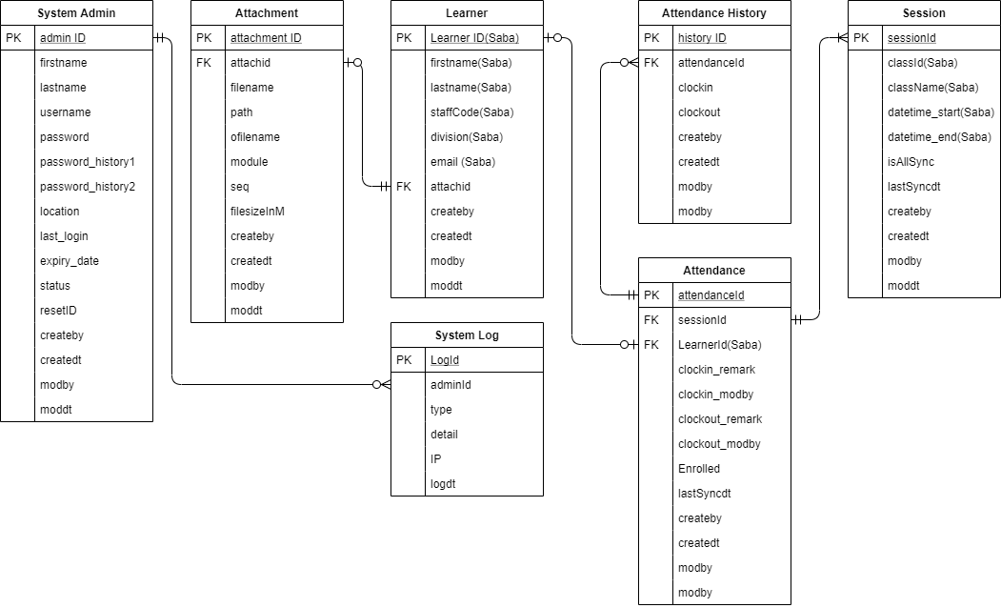

Interfacing

Overview
To make the attendance system works, it requires data transit between attendance system and Saba system. Below describe where, how and what data will be retrieved.
- Host of the Saba
UAT
LIVE
- Retrieve data from Saba by API
- Class & Session Information
Data to be retrieved
Field | Description
offeringId | classId
name | className
startDate.dateInUserTimeZone  startDate.timeInUserTimeZone | datetime_start
endDate.dateInUserTimeZone  endDate.timeInUserTimeZone | datetime_end
- Enrollment Information
Data to be retrieved
Field | Description
Student id | Learner id
Student email | Learner email
- Learner Information
Data to be retrieved
From | Description
fname | Learner firstname
lname | Leaner lastname
custom3 | Learner division
custom4 | Learner staffCode
displayName | Learner profile picture
- Upload attendance record to Saba by FTP
Data to be uploaded to Saba:

CSV format
Parameter | Value
classid | class id from Saba
session_startdatetimeInUserTimeZone | Session start datetime (format: YYYY-MM-DD HH:MM:SS)
session_enddatetimeInUserTimeZone | Session end datetime (format: YYYY-MM-DD HH:MM:SS)
clock in | Clock in datetime
clock out | Clock out datetime
duration_hours | Time different of clock in and clock out datetime in hours
duration_minutes | Time different of clock in and clock out datetime in minutes
trainingtime_hours | Time different of clock in and clock out datetime in hours, not larger than the session duration
trainingtime_minutes | Time different of clock in and clock out datetime in minutes, not larger than the session duration
- Get learner id from Enrollment QR code by API

Retrieve data from Saba

Cron Job
A Cron job will be run at everyday midnight (1 hours after HR sync job run from Saba) to retrieve class, session, learner and enrollment data from Saba. Below is the list of APIs which will call in the system.

Get Certificate
Retrieve the certificate token for all Saba API.
Source API (Get Certificate) /login
Parameter | Value
user | KEN@HASHTECHPRO.COM
Request:
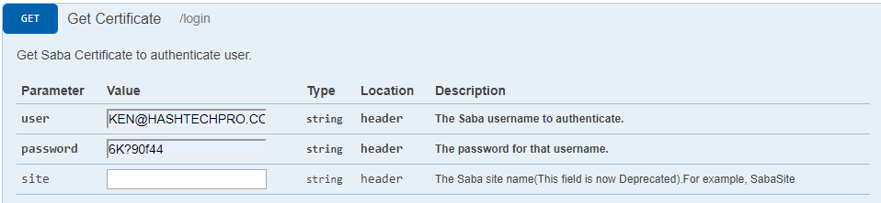
Response: 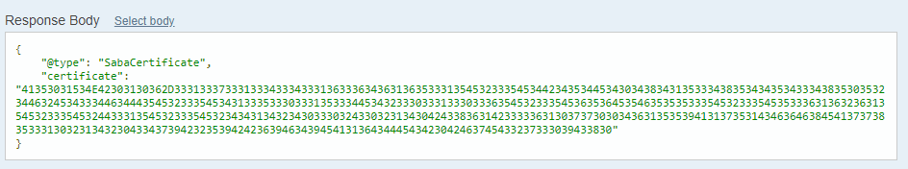

Get All Classes and Sessions
Step 1) Get All Classes
Source API (Get All Classes) /offering?type=:type&count=:count&startPage=:startPage
Parameter | Value
type | instructor_led
count | 30
startPage | 1
Remarks: Keep call this API until the “hasMoreResults” is false
Request: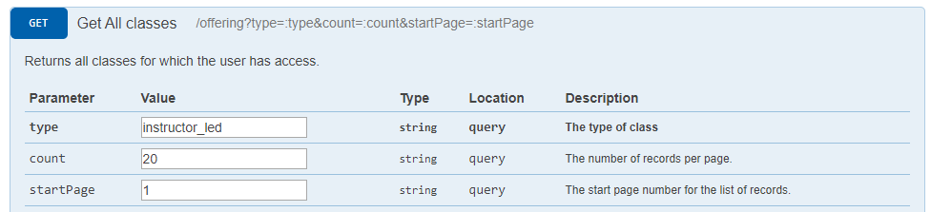
Response: 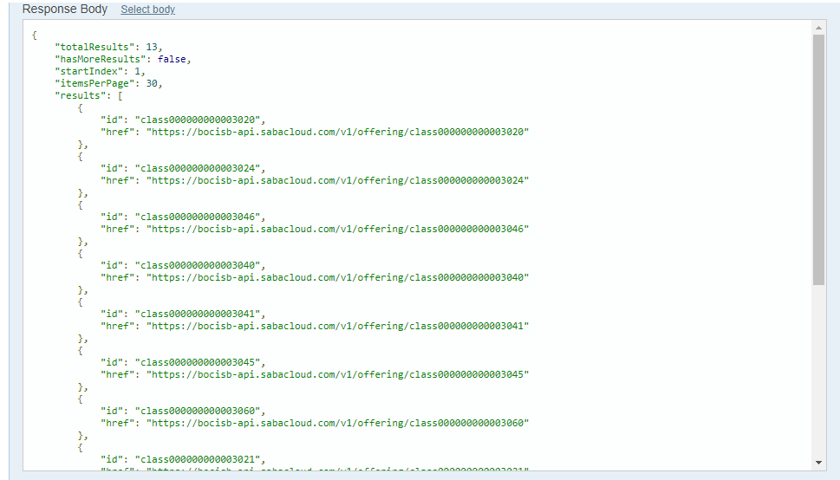

Step 2) Get Classes Details
Source API (Get the details of an class) /offering/:offeringId
Parameter | Value
offeringId | class000000000003020
context | admin
Remarks: Get the class name only
Request: 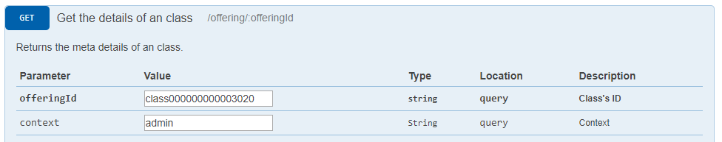
Response: 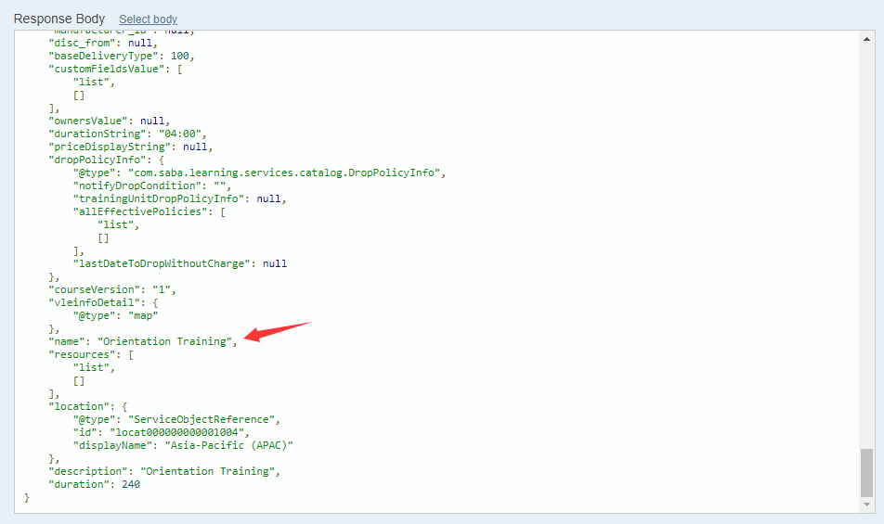

Step 3) Get Sessions Details
Source API (Retrieve all the sessions of an Offering) /offering/:offeringId/session
Parameter | Value
offeringId | class000000000003020
Remarks: get all unexpired sessions date and time.
For start date: sessionsInUserTimezone.list.startDate.dateInUserTimeZone
For start time: sessionsInUserTimezone.list.startDate.timeInUserTimeZone
For end date: sessionsInUserTimezone.list.endDate.dateInUserTimeZone
For end time: sessionsInUserTimezone.list.endDate.timeInUserTimeZone
Request: 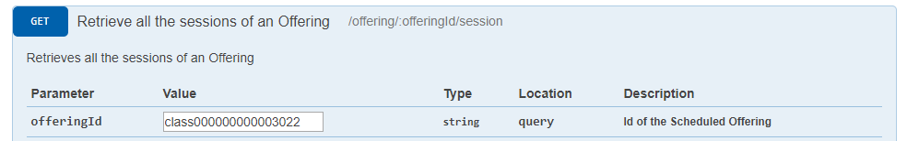
Response: 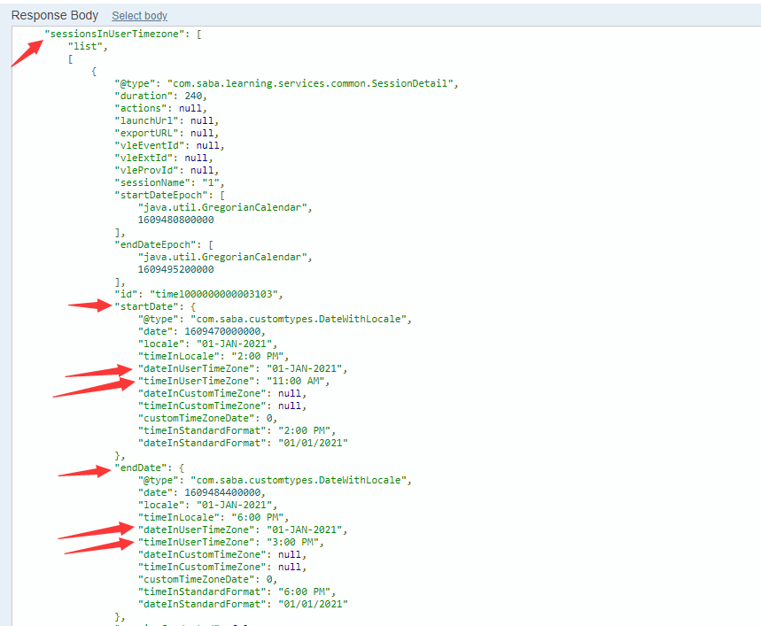
Destination:
Table “Session”
From | To Table Field
offeringId (step 1) | classId
name (step 2) | className
startDate.dateInUserTimeZone  startDate.timeInUserTimeZone | datetime_start
endDate.dateInUserTimeZone  endDate.timeInUserTimeZone | datetime_end

Get All Enrollment
Source API (Search enrollments based on given criteria) /learning/enroll/search?q=(:searchCriteria)&count=:count&startPage=:startPage&includeDetails=:includeDetails
Parameter | Value
searchCriteria | class_id==class000000000003020
count | 30
startPage | 1
includeDetails | true
Remarks: Keep call this API until the “hasMoreResults” is false
Request: 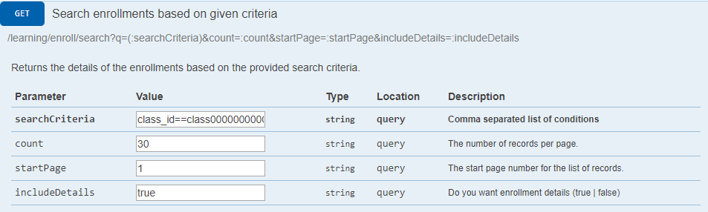
Response: 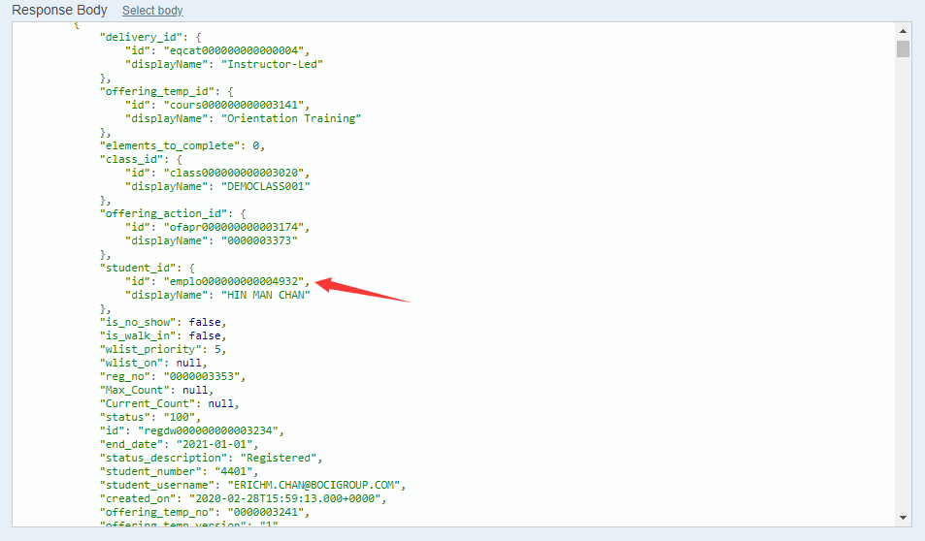
Destination:
Table “Attendance”
From | To Table Field
student_id | LearnerId
Student_email | email

Get All Learner and details
Step 1) Get All Learner
Source API (Get All Persons (Internal/External)) /people?type=:type&count=:count&startPage=:startPage
Parameter | Value
type | internal
count | 30
startPage | 1
Remarks: Keep call this API until the “hasMoreResults” is false
Request: 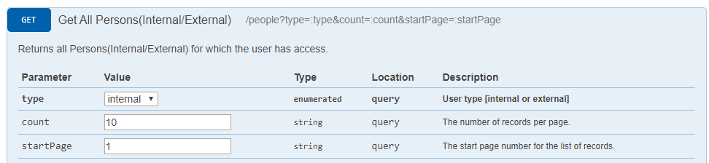
Response: 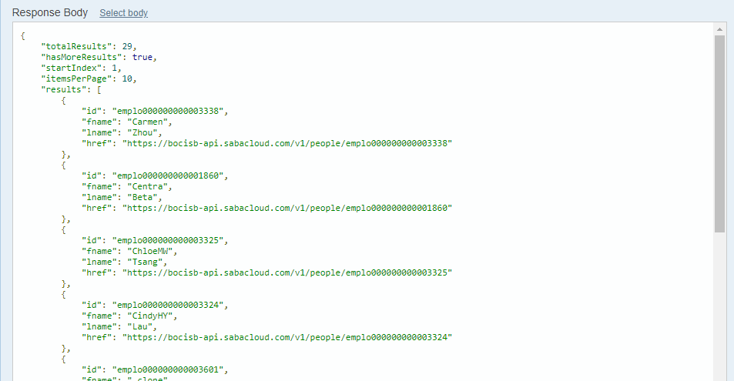

Step 2) Get Learner’s BOCI staff code / division / staff name
Source API (Find profile information) /people?type=:type&f=(:searchFields)&q=(:query)&count=:count&startPage=:startPage
Parameter | Value
type | internal
searchFields | custom3,custom4,fname,lname
query | id==emplo000000000003321
count | 10
startPage | 1
Remarks: get BOCI staff code and Learner picture (only get picture when system don’t have)
Request: 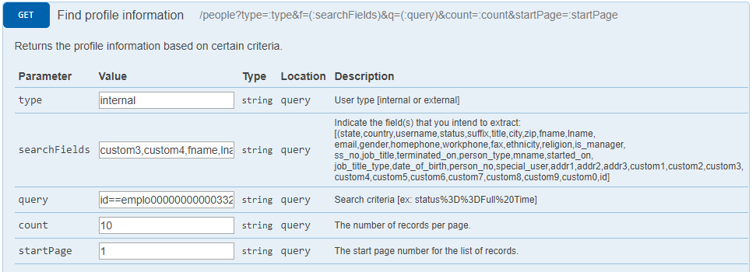
Response: 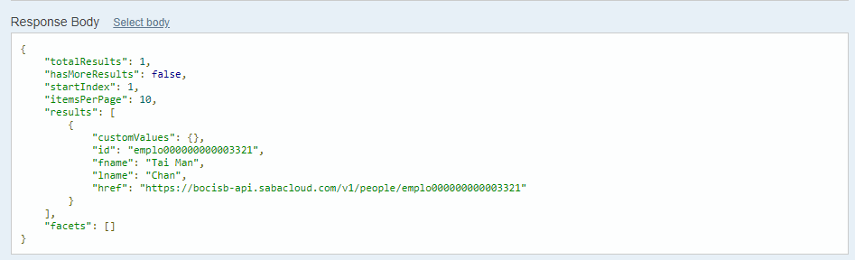
Step 3) Get Learner’s profile image
Source API (GET Profile Pic URL)
/common/profile/:personId/profilePicURL
Parameter | Value
psersonId | emplo000000000005698
Remarks: get BOCI staff code and Learner picture (only get picture when system don’t have)
Request: 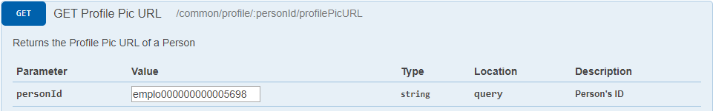
Response: 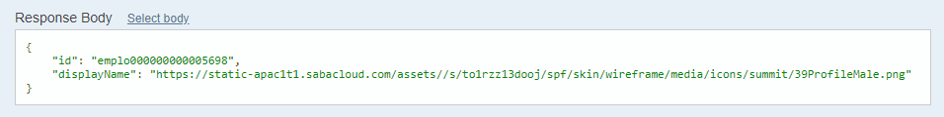
Destination:
Table “Learner”
From | To Table Field
fname(Step 1) | firstname
lname(Step 1) | lastname
custom3(Step 2) | division
custom4(Step 2) | staffCode
displayName(Step 3) | Attachment table

Enrollment QR code
The QR code will provide personPictureURL, registrationId. Use registrationId to call API retrieving the learnerId.
Source API (Get the details of an enrollment) /enrollments/:id/sections::sections
Parameter | Value
id | regdw000000000003183
sections | regdetail
Remarks: get learnerId only.
Request: 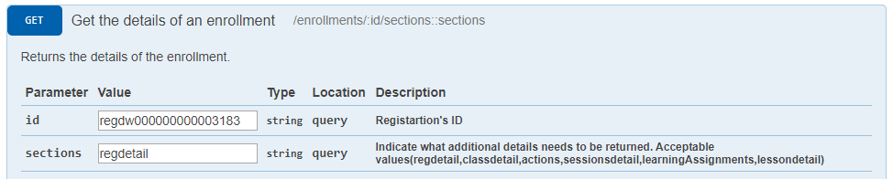
Response: 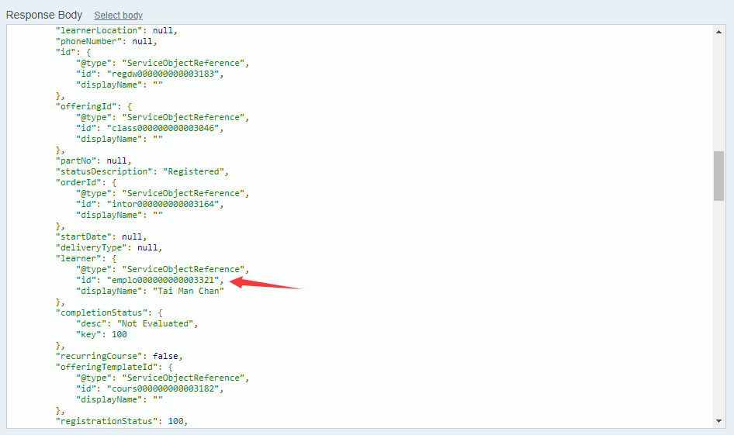

Learner QR code
The QR code will provide learner name(fn), learner id(id) and profile picture. Use learner id find the enrollment information in attendance system.

Upload attendance record to Saba System
After the class / session end, System administrator can upload the attendance record to Saba.
Synchronize step:
- System administrator check the correctness of the attendance record. If okay, they select the record that want to upload and press “Sync selected” button.
- Attendance system will generate a csv and upload to Saba System.

CSV format
Parameter | Value
classid | class id from Saba
session_startdatetimeInUserTimeZone | Session start datetime (format: YYYY-MM-DD HH:MM:SS)
session_enddatetimeInUserTimeZone | Session end datetime (format: YYYY-MM-DD HH:MM:SS)
clock in | Clock in datetime
clock out | Clock out datetime
duration_hours | Time different of clock in and clock out datetime in hours
duration_minutes | Time different of clock in and clock out datetime in minutes
trainingtime_hours | Time different of clock in and clock out datetime in hours, not larger than the session duration
trainingtime_minutes | Time different of clock in and clock out datetime in minutes, not larger than the session duration

System Security
- All data transmit in SSL
- User will force logout the mobile app after 15 minutes idle time
- Backend system configuration of which device could be login

Appendix
Frontend Prototype: https://xd.adobe.com/view/41b71fa4-2f52-43ba-7489-420aa69efbb8-3786/
Frontend Prototype V2: https://xd.adobe.com/view/6149bf78-2bb7-447d-5bac-caa4e073fbb0-1778/
Frontend Prototype V3: https://xd.adobe.com/view/0ecec4d7-bb7c-4553-56f6-ca595209de10-78ff/
Backend Prototype: http://boci.hashtechpro.com/login.php

